**Visoka ICT škola**

Beograd, Zdravka Čelara

**Dokumentacija interaktivnog web sajta – Laravel framework (Web programiranje PHP 2)**

Student:

Milica Pavlović 73/17

Beograd, mart 2021.

Sadržaj

1.Uvod 4

1.1 Korišćeni programski jezici 4

1.2 Opis funkcionalnosti 4

1.3 Template 8

1.4. Slika baze 8

2. Organizacija 9

2.1 Mapa sajta 9

2.2 Slike stranica i opisi funkcionalnosti 11

2.3.1 home.blade.php 11

2.3.2 product.blade.php 13

2.3.3 onama.blade.php 14

2.3.4 location.blade.php 15

2.3.5 kontakt.blade.php 16

2.3.6 galerija.blade.php 17

2.3.7 admin.blade.php 18

2.3.8 admin/users/index.blade.php 19

2.3.9 admin/users/create.blade.php 20

2.3.10 admin/users/edit.blade.php 20

2.3.11 admin/users/activity.blade.php 21

2.3.12 admin/products/index.blade.php 22

2.3.13 admin/products/create.blade.php 23

2.3.14 admin/products/edit.blade.php 24

2.3.15 user/edit.blade.php 25

2.3.16 pages/autor.blade.php 26

3. Kodovi 27

3.0 routes/web.php 27

3.1 App/Http/Controllers 28

3.1.1 App/Http/Controllers/OsnovniController.php 28

3.1.2 App/Http/Controllers/HomeController.php 30

3.1.3 App/Http/Controllers/OnamaController.php 31

3.1.4 App/Http/Controllers/ProductController.php 31

3.1.5 App/Http/Controllers/LokacijeController.php 32

3.1.6 App/Http/Controllers/KontaktController.php 32

3.1.1 App/Http/Controllers/GalerijaController.php 33

3.1.7 App/Http/Controllers/AdminController.php 33

3.2 App/Http/Controllers/AdminPanel 33

3.2.1 App/Http/Controllers/ProductController.php 33

3.2.2 App/Http/Controllers/UserController.php 36

3.2.3 App/Http/Controllers/LocationController.php 39

3.2.4 App/Http/Controllers/GalleryController.php 40

3.3 App/Http/Controllers/UserControllers 40

3.3.1 App/Http/Controllers/UserController.php 40

3.4 App/Http/Requests 41

3.4.1 App/Http/Requests/StoreProductController.php 41

3.4.2 App/Http/Requests/StoreUserController.php 42

3.5 App/Http/Middleware 43

3.5.1 App/Http/Middleware/IpLoggingMiddleware.php 43

3.6 App/Models 43

3.6.1 App/Models/About_us.php 43

3.6.2 App/Models/Autor.php 44

3.6.3 App/Models/Category.php 44

3.6.4 App/Models/Gallery.php 45

3.6.5 App/Models/Location.php 45

3.6.6 App/Models/Nav_link.php 45

3.6.7 App/Models/Navbar.php 46

3.6.8 App/Models/Product.php 46

3.6.9 App/Models/Useractivity.php 48

3.6.10 App/Models/Users.php 48

3.6.11 App/Models/ 50

3.7 public 50

3.7.1 public/assets/css/style.css 50

3.7.2 public/assets/js/main.js 53

3.8 resources/views/layouts 62

3.8.1 resources/views/layouts/layout.blade.php 62

3.8.2 resources/views/layouts/admin.blade.php 62

3.9 resources/views/fixed 63

3.9.1 resources/views/fixed/404.blade.php 63

3.9.2 resources/views/fixed/adminPageLinks.blade.php 63

3.9.3 resources/views/fixed/footer.blade.php 64

3.9.4 resources/views/fixed/head.blade.php 67

3.9.5 resources/views/fixed/message.blade.php 67

3.9.6 resources/views/fixed/nav.blade.php 68

3.9.7 resources/views/fixed/scripts.blade.php 69

3.10 resources/views/partials 69

3.10.1 resources/views/fixed/product.blade.php 69

3.11 resources/views/pages 69

3.11.1 resources/views/pages/autor.blade.php 69

3.11.2 resources/views/pages/ 70

# 1.Uvod

## 1.1 Korišćeni programski jezici

Za izradu sajta Kaficomika korišćene su sledeće tehnologije: HTML, CSS, bootstrap, java script, jQuery v3-2-1, AJAX, PHP Laravel framework, rad nad bazom u PHPmyAdmin i skladištenje podataka u sesije.

## 1.2 Opis funkcionalnosti

Ono što važi za ceo *Kaficomika* sajt je:

* Sajt je responsive
* Dinamičko ispisivanje celokupnog sadržaja iz baze
* Organizovan je u 2 layouta, jednim koji ima funkciju da prikaže sadržaj namenjen svima, neautorizovanim korisnicima (layout.blade.php) i jednim namenjenim autorizovanim korisnicima (admin.blade.php)
* Dinamičko ispisivanje grešaka iz javascripta ili controllera

home.blade.php, onama.blade.php, lokacije.blade.php, galerija.blade.php, autor.blade.php:

* Dinamičko ispisivanje celokupnog sadržaja iz baze i dinamičko ispisivanje obaveštenja u slučaju logovanja ili registracije
* Dinamičko ispisivanje grešaka

product.blade.php:

* Funkcioalnost usklađenog filtriranja po kategoriji, sortiranja po ceni i paginacije putem ajax-a
* Klikom na ime ili sliku proizvoda otvara se detaljan prikaz informacija o konkretnom proizvodu

logovanje i registracija:

* Dinamicko ispisivanje obaveštenja o uspešnosti logovanja/registracije na početnoj strani

admin.blade.php:

* Dinamicko ispisivanje svih stavki vezanih za admin panel

users.blade.php:

* Funkcioalnost usklađenog sortiranja po id-ju korisnika, nazivu i momentu registracije, paginacija, pretraga po imenu korisnika – sve putem ajax-a
* Funkcionalnost validacije unetih podataka, ispis grešaka
* Funkcionalnost dodavanja novog korisnika, izmene, brisanja i prikaza aktivnosti konkretnog korisnika

products.blade.php:

* Funkcioalnost usklađenog sortiranja po id-ju proizvoda, nazivu i ceni, paginacija, pretraga po nazivu proizvoda – sve putem ajax-a
* Funkcionalnost dodavanja novog proizvoda, izmene, brisanja putem ajaxa konkretnog proizvoda
* Funkcionalnost validacije unetih podataka, ispis grešaka

activity.blade.php:

* Funkcioalnost usklađenog filtriranja po datumu aktivnosti i paginacije – sve putem ajax-a
* Funkcionalnost brisanja putem ajaxa konkretne aktivnosti odabranog korisnika

user.blade.php:

* Funkcioalnost izmene profila ulogovanog korisnika, konkretno izmena korisničkog imena, lozinke i e-maila, kao i deaktivacija naloga, nakon čega se korisnik automatski logout-uje i više ne može da se uloguje sa starim kredencijalima
* Funkcionalnost validacije unetih podataka, ispis grešaka

## 1.3 Template

Koristila sam svoj template

## 1.4. Slika baze

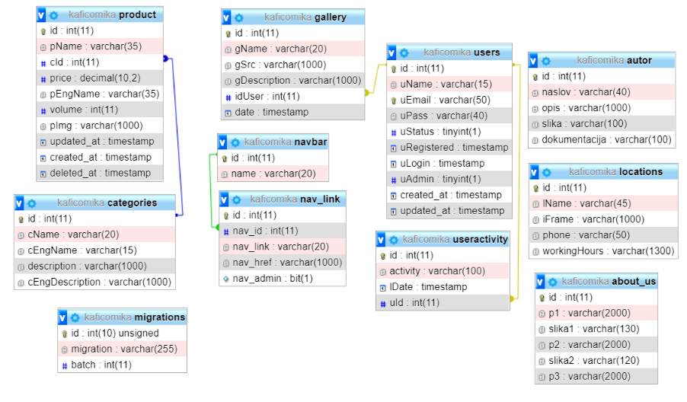

# 2. Organizacija

## 2.1 Mapa sajta

<?xml version="1.0" encoding="utf-8"?>

<urlset xmlns="http://www.sitemaps.org/schemas/sitemap/0.9">

<url>

<loc>https:// http://kaficomika.ml/public/</loc>

<lastmod>2021-13-03</lastmod>

<changefreq>monthly</changefreq>

<priority>0.9</priority>

</url>

<url>

<loc>https:// http://kaficomika.ml/public/</loc>

<lastmod>2021-13-03</lastmod>

<changefreq>monthly</changefreq>

<priority>0.8</priority>

</url>

<url>

<loc>https:// http://kaficomika.ml/public/</loc>

<lastmod>2021-13-03</lastmod>

<changefreq>monthly</changefreq>

<priority>0.7</priority>

</url>

<url>

<loc>https:// http://kaficomika.ml/public/</loc>

<lastmod>2021-13-03</lastmod>

<changefreq>yearly </changefreq>

<priority>0.6</priority>

</url>

<url>

<loc>https:// http://kaficomika.ml/public/</loc>

<lastmod>2021-13-03</lastmod>

<changefreq>yearly</changefreq>

<priority>0.5</priority>

</url>

<url>

<loc>https:// http://kaficomika.ml/public/</loc>

<lastmod>2021-13-03</lastmod>

<changefreq>yearly</changefreq>

<priority>0.4</priority>

</url>

</urlset>

## 2.2 Slike stranica i opisi funkcionalnosti

### 2.3.1 home.blade.php

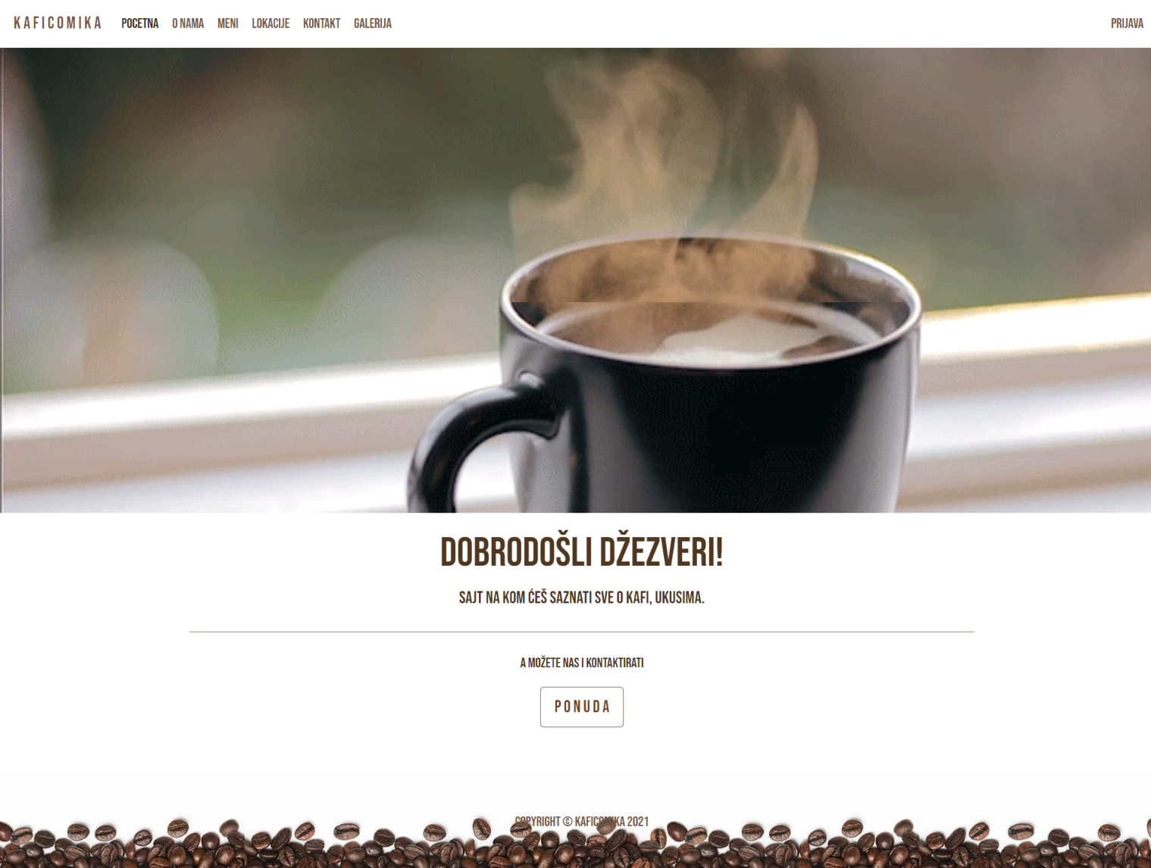

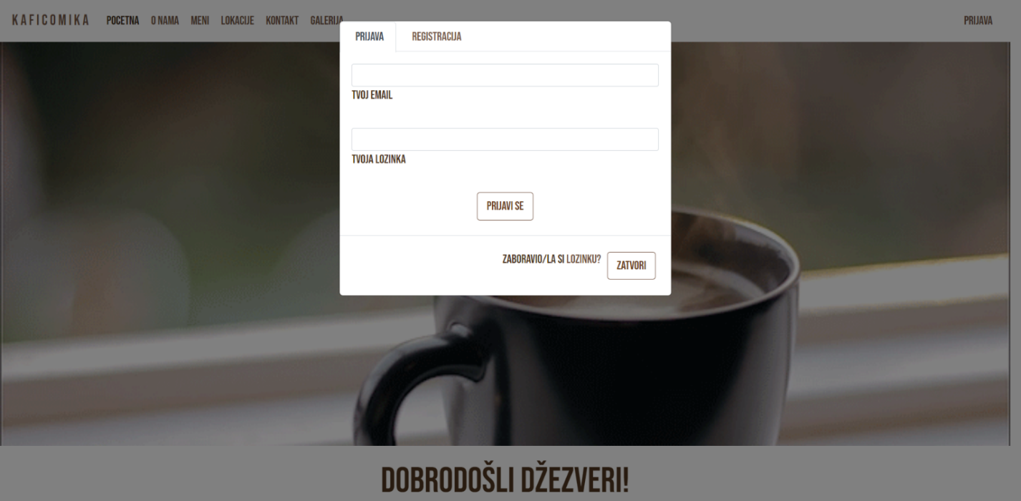

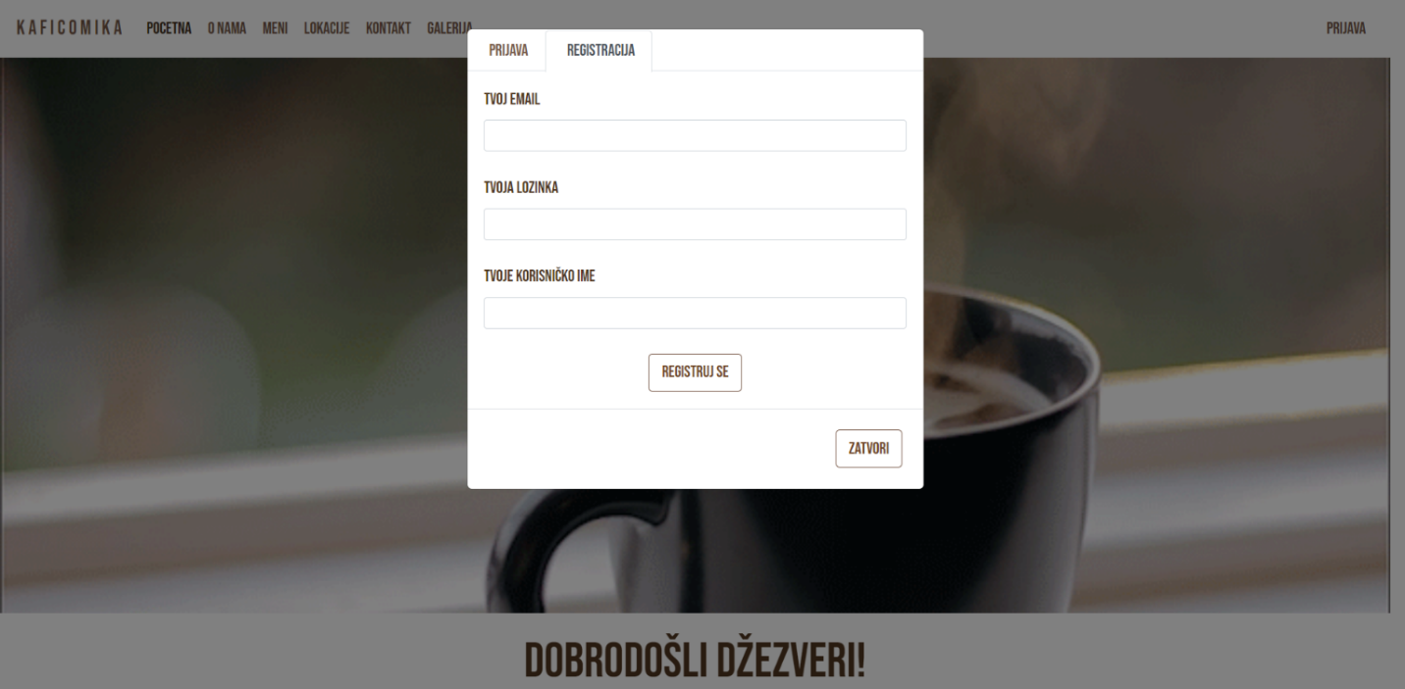

Dinamički unet sadržaj footera i headera. Dinamički ispis obaveštenja i grešaka iz kontrolera, validacija.

### 2.3.2 product.blade.php

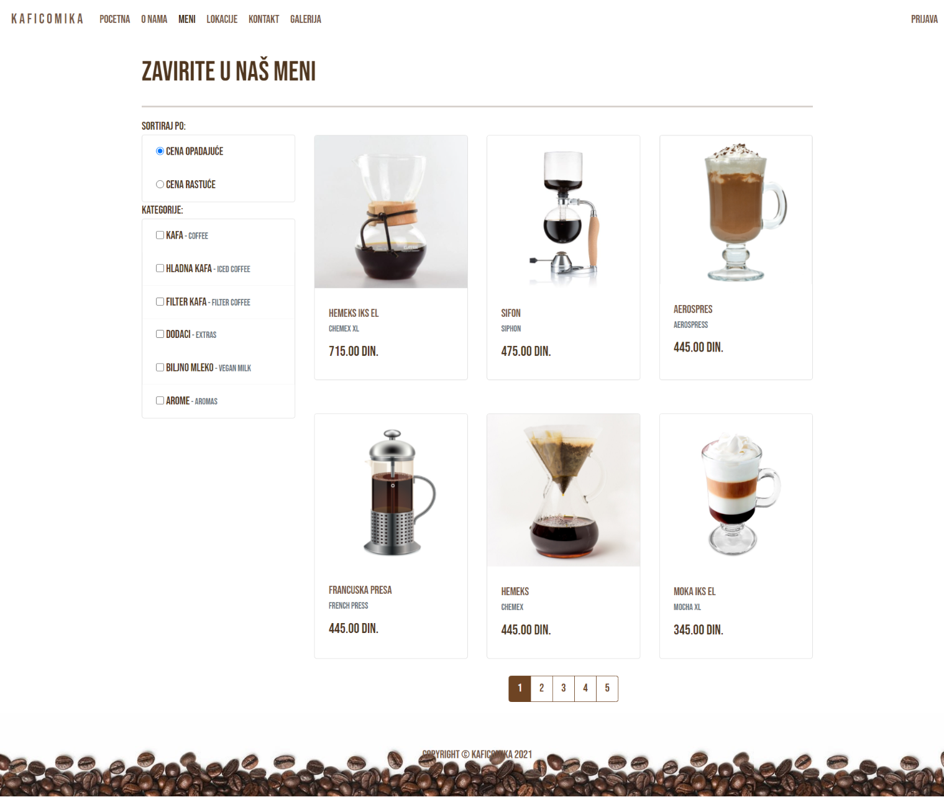

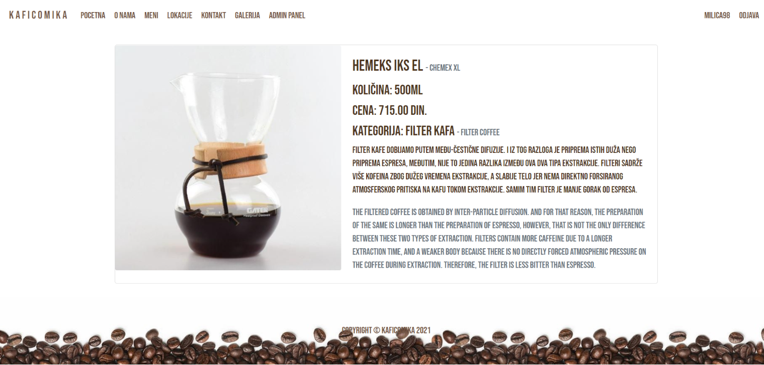

Na ovoj stranici dinamički su ispisani proizvodi. Usklađena unkcionalnost filtriranja po kategorijama, sortiranja po ceni i paginacije.

### 2.3.3 onama.blade.php

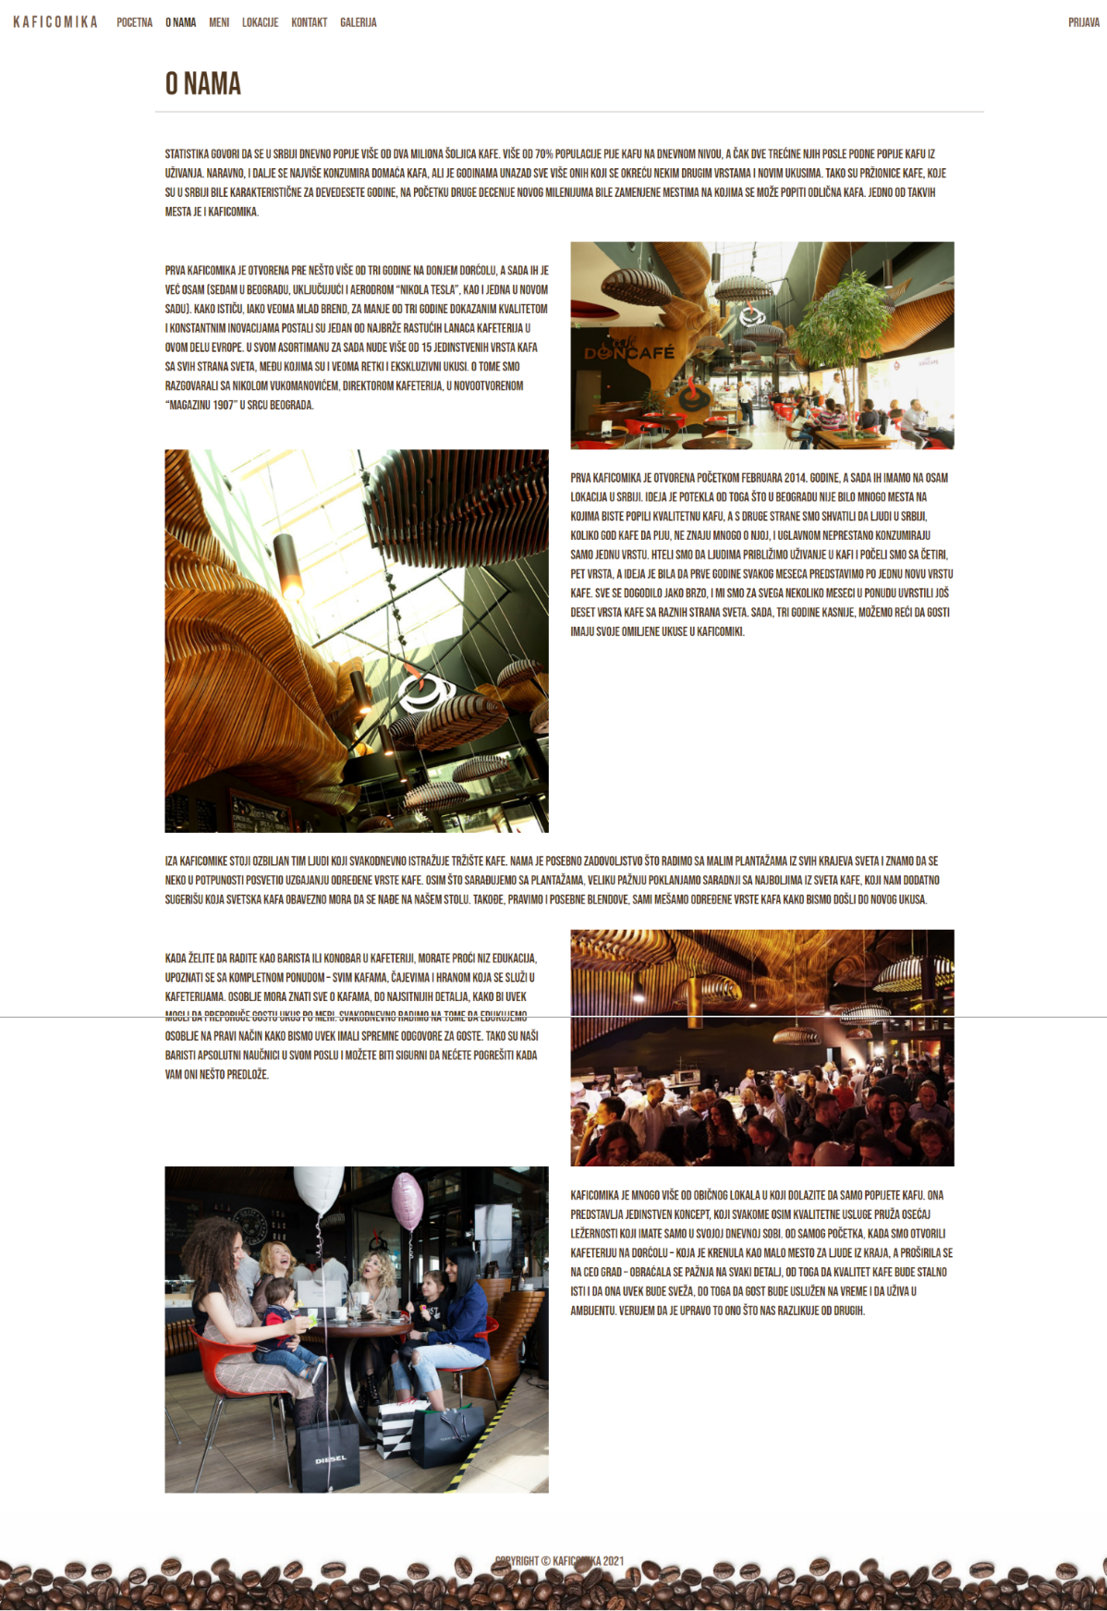

Sadržaj dinamički učitan iz baze.

### 2.3.4 location.blade.php

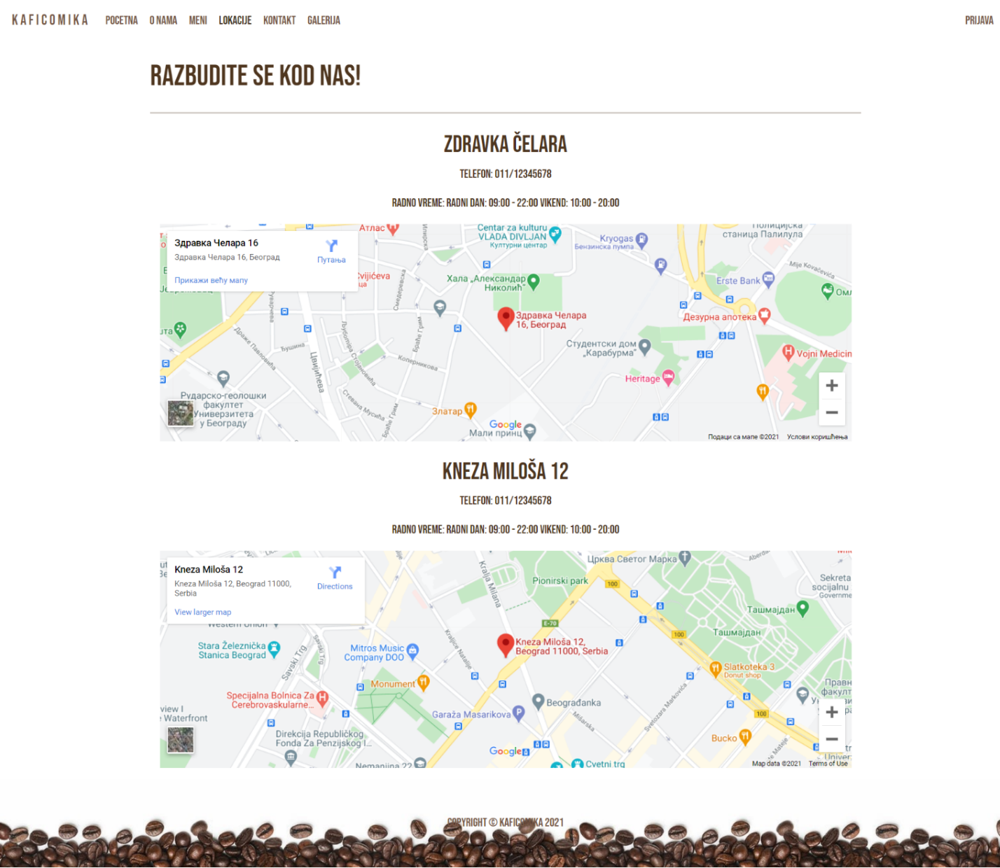

Kompletan sadržaj dinamički učitan iz baze.

### 2.3.5 kontakt.blade.php

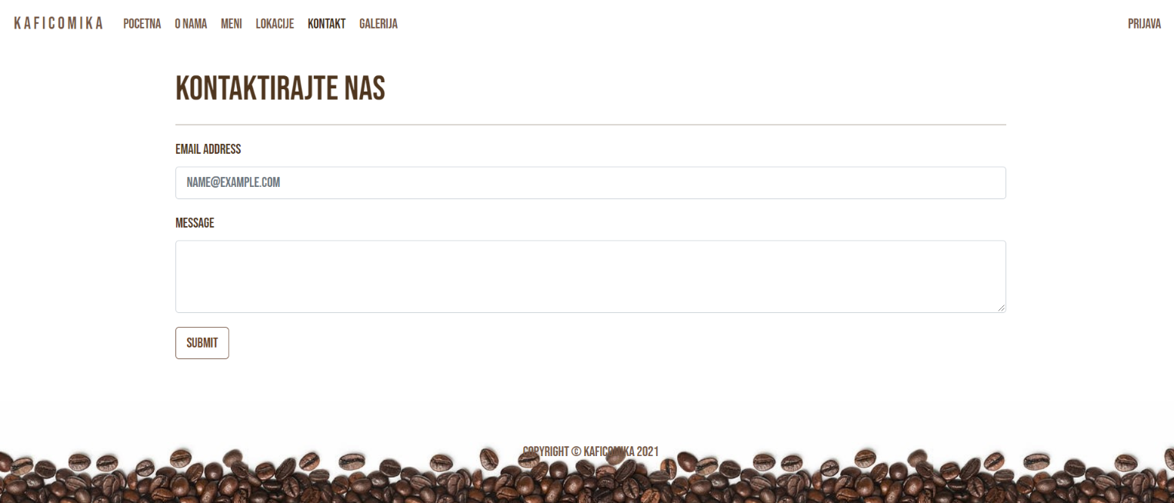

Stranica namenjena kontaktiranju administratora.

### 2.3.6 galerija.blade.php

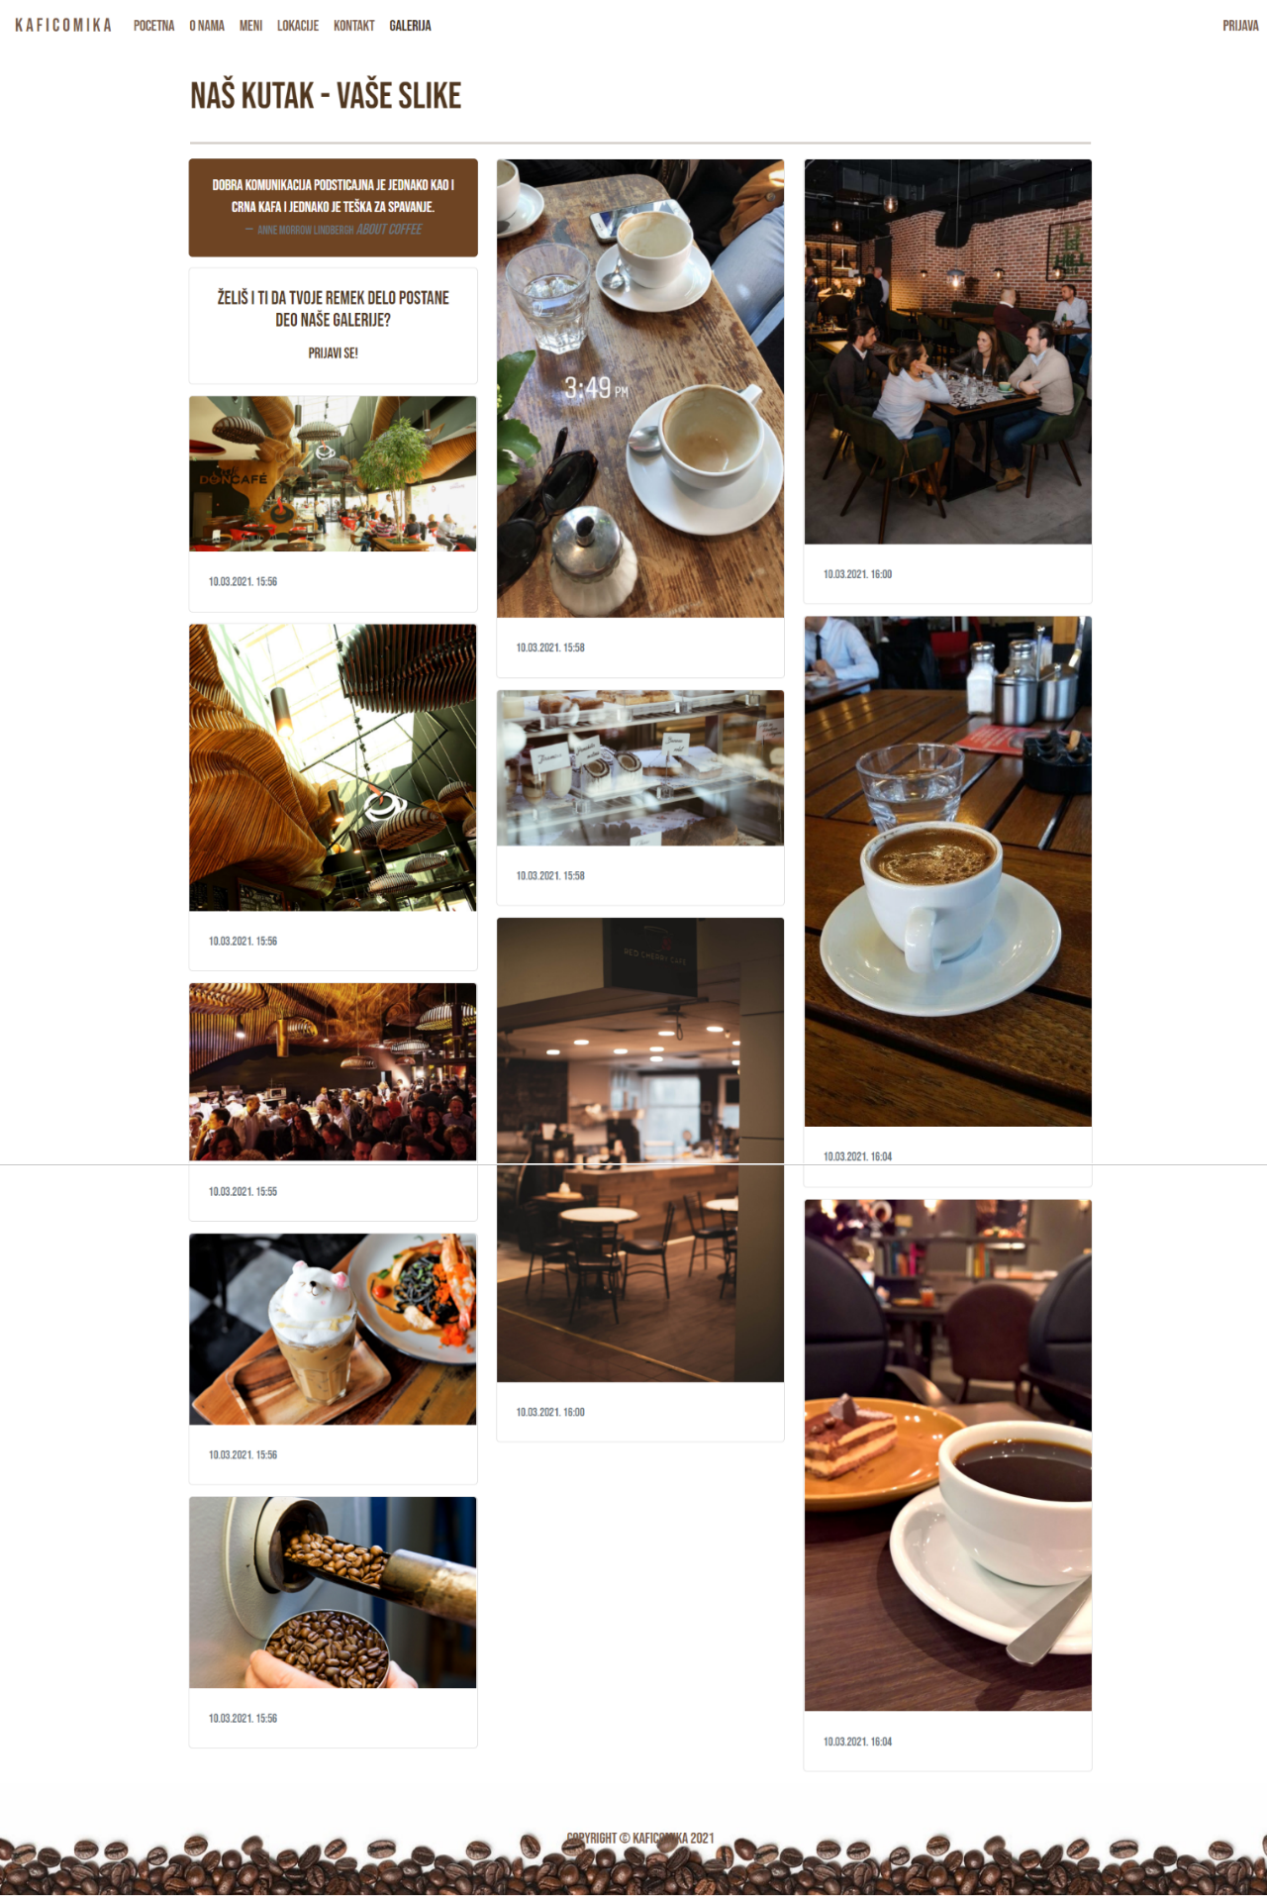

Dinamički unet sadržaj iz baze. Datum objave preformatiran iz timestamp formata.

## 2.3.7 admin.blade.php

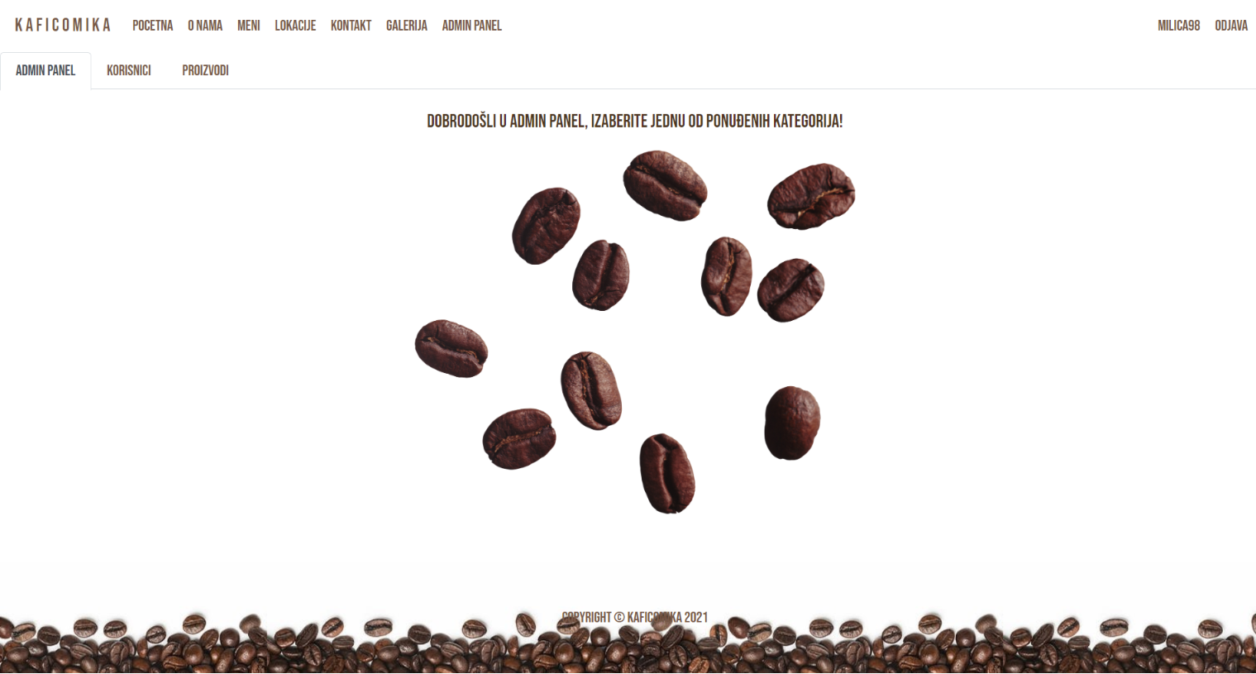

Logovanjem sa adminsitratorskim parametrima navigacioni meni dobija dva nova linka: admin i odjava. Admin vodi na admin panel koji poseduje podesavanja kosrisnika, proizvoda, galerije, lokacija i stranice „O nama“. Korisnici se mogu brisati i njihovi podaci editovati i postoji mogucnost dodavanja novog korisnika. Isto vazi i za ostale oblasti sajta čijoj izmeni admin panel pruza pristup.

## 2.3.8 admin/users/index.blade.php

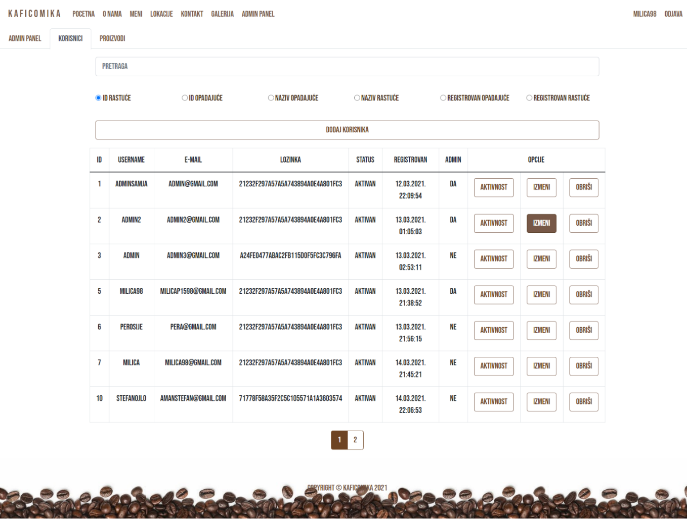

Dinamički izlistani svi korisnici u tabelarnom prikazu.

Funkcionalnost pretrage username-a, filtriranja po imenu rastuće i opadajuće, id-ju i datumu registracije korisnika.

Datum objave preformatiran iz timestamp formata.

## 2.3.9 admin/users/create.blade.php

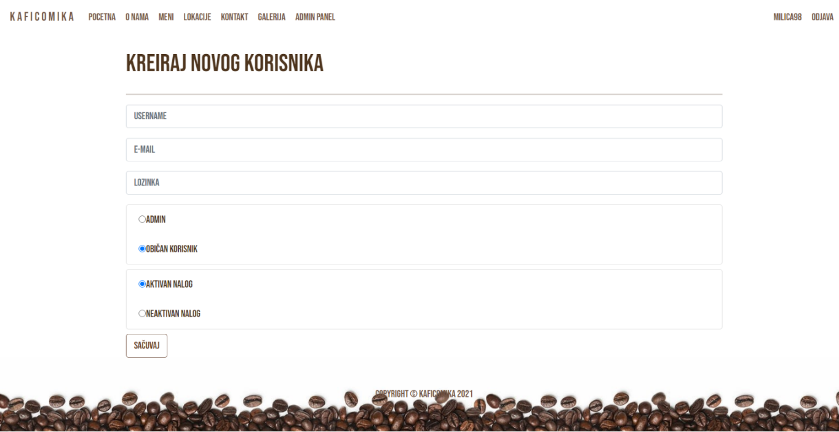

## 2.3.10 admin/users/edit.blade.php

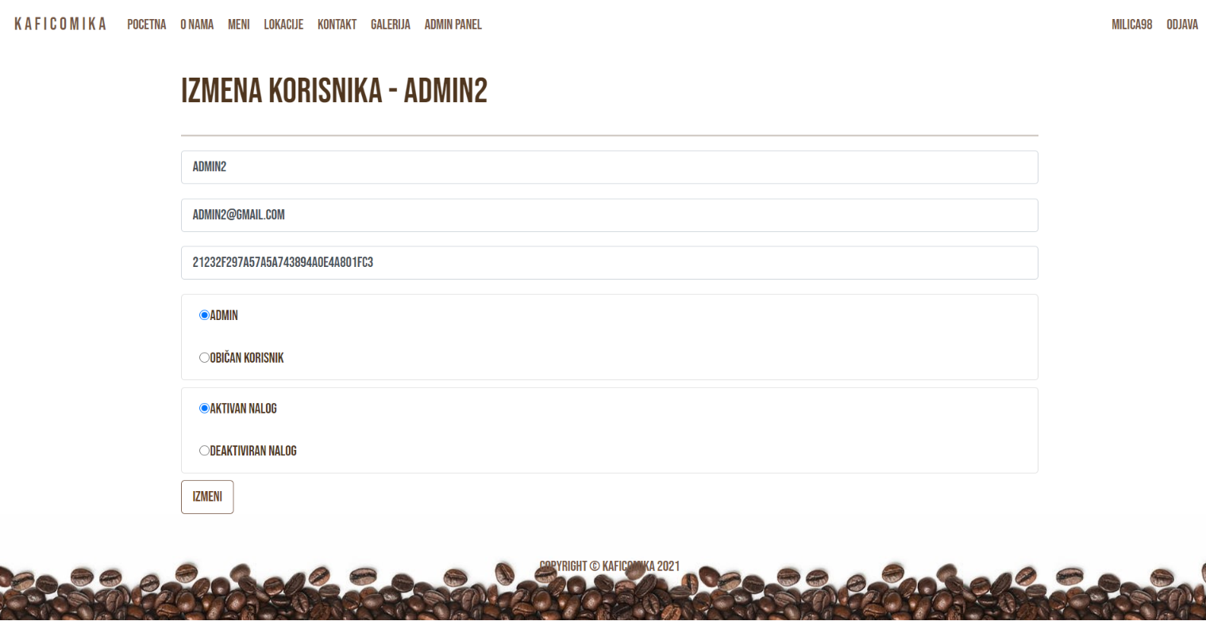

Forma za izmenu dinamički popunjena podacima iz baze. Validacija sprečava unos korisnika sa e-mailom koji već postoji u bazi. Dinamičko ispisivanje ispravnosti unosa novog korisnika.

## 2.3.11 admin/users/activity.blade.php

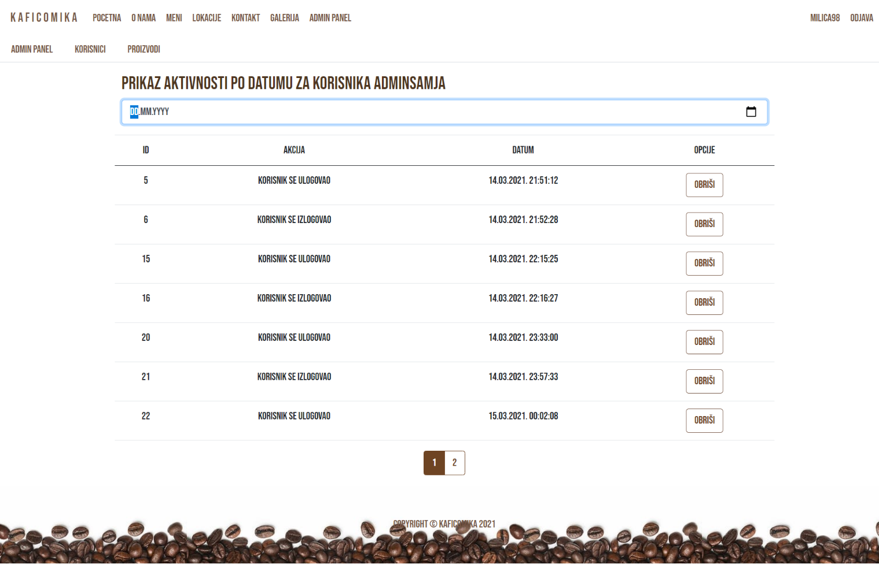

Dinamički prikaz svih aktivnosti odabranog korisnika.

Funkcionalnost usklađenih paginacije, filtera po datumu i brisanja aktivnosti odrađeni putem ajax-a.

Datum preformatiran iz timestamp formata koji je došao iz baze.

## 2.3.12 admin/products/index.blade.php

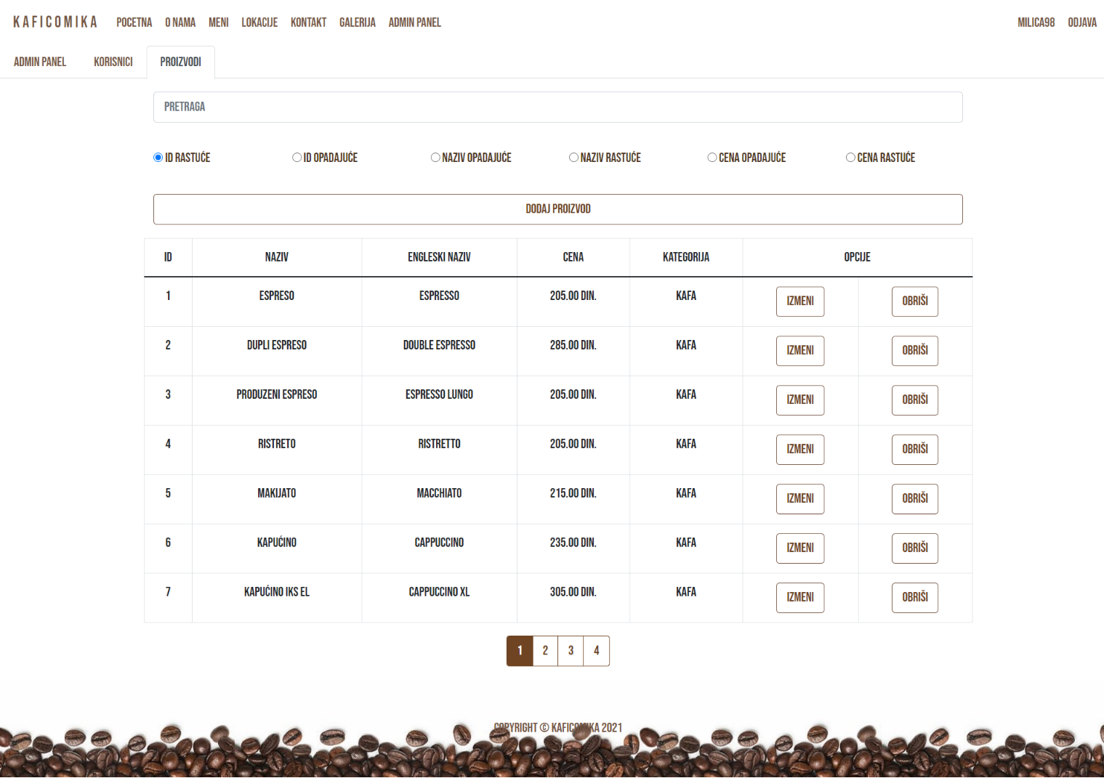

Dinamički prikaz svih proizvoda iz baze.

Funkcionalnost usklađenih pretrage, paginacije, sorta i brisanja proizvoda odrađeni putem ajax-a.

## 2.3.13 admin/products/create.blade.php

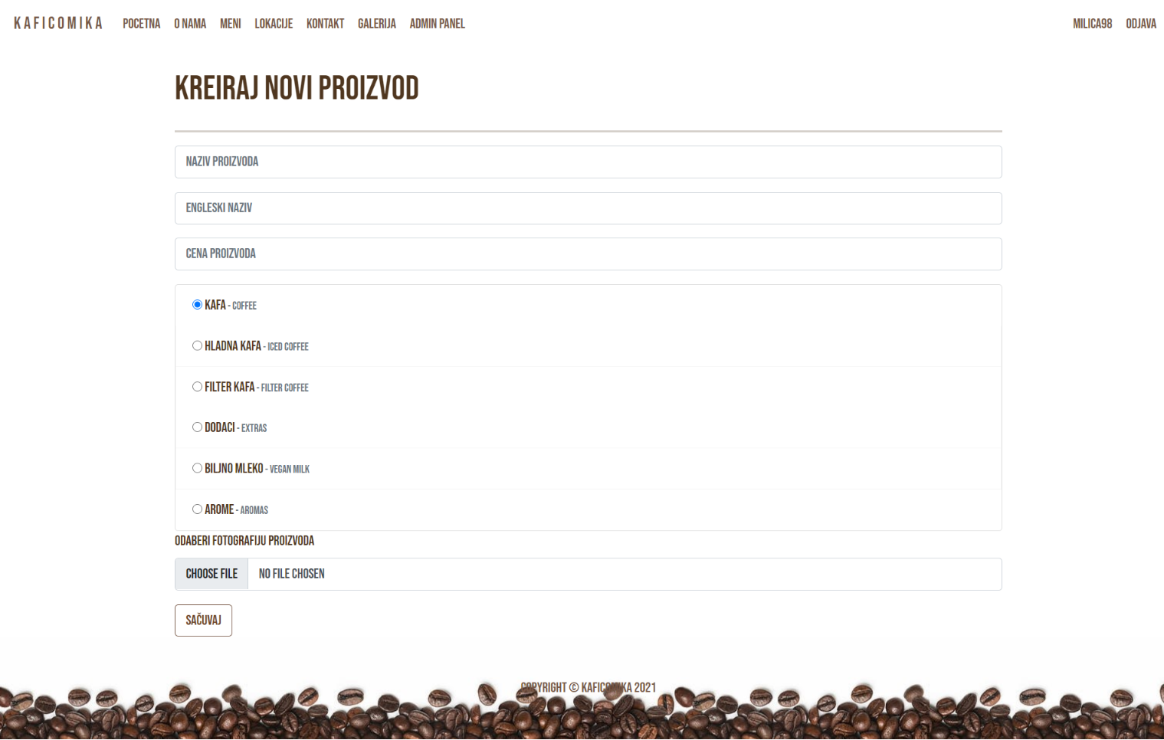

Inicijalno je selektovana prva kategorija. Dinamička obaveštenja o unosu.

## 2.3.14 admin/products/edit.blade.php

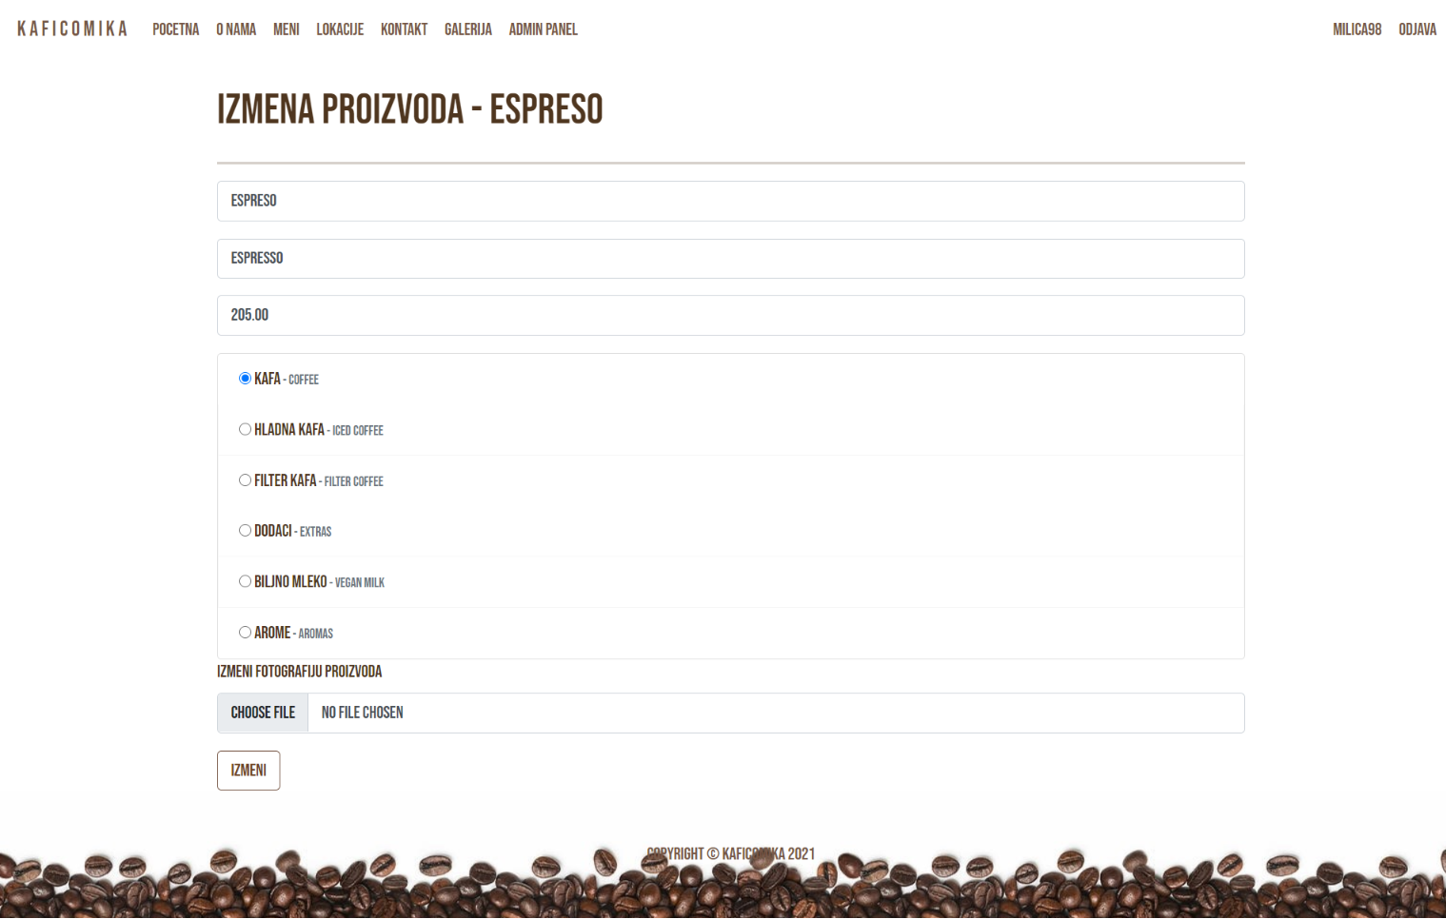

Forma za izmenu dinamički popunjena podacima iz baze. Validacija sprečava nepravilan unos. Dinamičko ispisivanje ispravnosti unosa novog proizvoda.

## 2.3.15 user/edit.blade.php

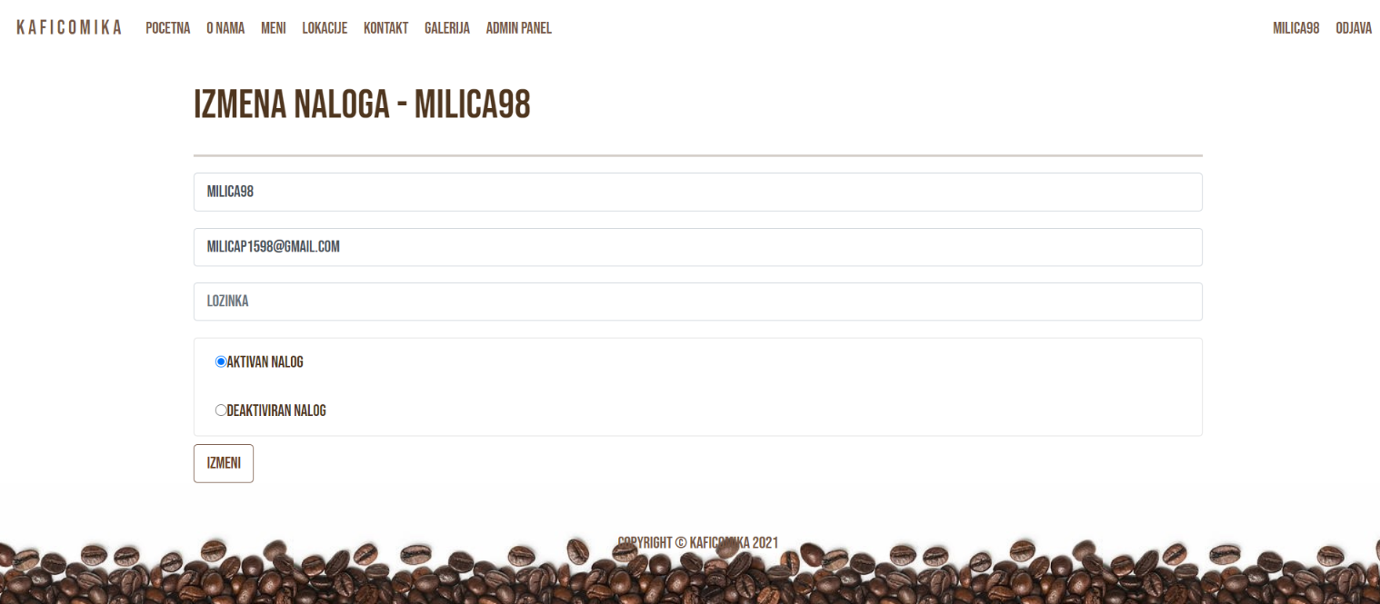

Forma za izmenu dinamički popunjena podacima iz baze, izuzev lozinke. Validacija sprečava izmenu e-maila ako novi već postoji u bazi. Dinamičko ispisivanje ispravnosti unosa novog korisnika.

U slučaju da korisnik odabere deaktiviran nalog, automatski biva izlogovan i više se ne može ulogovati sa istim kredencijalima.

## 2.3.16 pages/autor.blade.php

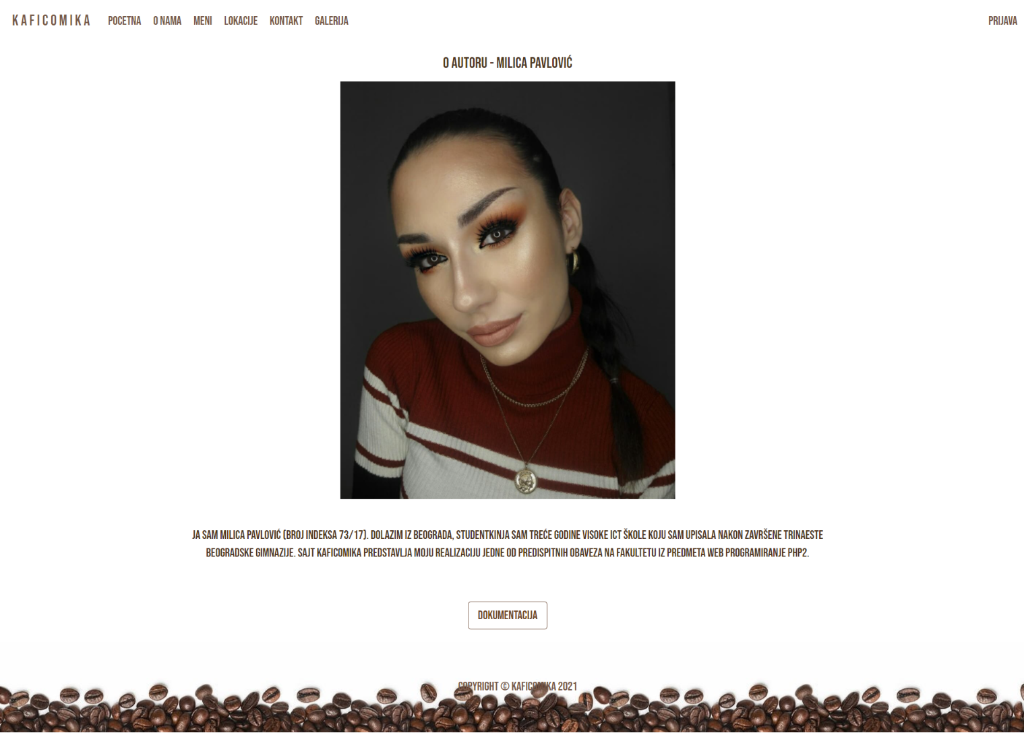

Dinamički unet sadržaj o autoru, dokumentacija.

# 3. Kodovi

## 3.0 routes/web.php

<?php  
  
namespace App\Http\Controllers;  
  
use App\Http\Controllers\AdminPanel\UserController;  
use Illuminate\Support\Facades\Route;  
  
  
/*  
|--------------------------------------------------------------------------  
| Web Routes  
|--------------------------------------------------------------------------  
|  
| Here is where you can register web routes for your application. These  
| routes are loaded by the RouteServiceProvider within a group which  
| contains the "web" middleware group. Now create something great!  
|  
*/  
  
  
Route::get(**'/'**, [HomeController::class, **'index'**])->name(**'home'**);  
Route::get(**'/onama'**, [OnamaController::class, **'index'**])->name(**'onama'**);  
Route::get(**'/kontakt'**, [KontaktController::class, **'index'**])->name(**'kontakt'**);  
Route::get(**'/admin'**, [AdminController::class, **'index'**])->name(**'admin'**);  
Route::get(**'/lokacije'**, [LokacijeController::class, **'index'**])->name(**'lokacije'**);  
  
Route::get(**'/product'**, [ProductController::class, **'index'**])->name(**'product'**);  
Route::get(**'/product/filtered'**, [ProductController::class, **'getFiltered'**]);  
Route::get(**'/product/{id}'**, [ProductController::class, **'show'**])->name(**'product.show'**);  
  
  
  
Route::prefix(**'admin'**)->group(function () {  
 Route::get(**'/product/filtered'**, [AdminPanel\ProductController::class, **'getFiltered'**]);  
 Route::get(**'/users/filtered'**, [AdminPanel\UserController::class, **'getFiltered'**]);  
 Route::get(**'/users/activity/{id}/filtered'**, [AdminPanel\UserController::class, **'getFilteredActivity'**]);  
  
  
 Route::get(**'/users/{id}/activity'**, [AdminPanel\UserController::class, **'activity'**])->name(**'users.activity'**);  
 Route::get(**'/users/activity/{id}'**, [AdminPanel\UserController::class, **'destroyActivity'**])->name(**'users.destroyActivity'**);  
  
  
 Route::resource(**'/products'**, AdminPanel\ProductController::class);  
 Route::resource(**'/users'**, AdminPanel\UserController::class);  
 Route::resource(**'/statistics'**, AdminPanel\StatisticsController::class);  
  
});  
  
  
Route::get(**'/galerija'**, [GalerijaController::class, **'index'**])->name(**'galerija'**);  
Route::get(**"/logout"**, [OsnovniController::class, **'logout'**])->name(**"logout"**);  
Route::post(**"/login"**, [OsnovniController::class, **'login'**])->name(**"login"**);  
Route::post(**"/register"**, [OsnovniController::class, **'register'**])->name(**"register"**);  
Route::get(**"/user"**, [UserControllers\UserController::class, **'index'**])->name(**"user"**);  
Route::put(**"/user/{id}/update"**, [UserControllers\UserController::class, **'update'**])->name(**"user.update"**);  
Route::get(**"/autor"** , [OsnovniController::class, **'autor'**])->name(**"autor"**);

## 3.1 App/Http/Controllers

### 3.1.1 App/Http/Controllers/OsnovniController.php

<?php  
  
namespace App\Http\Controllers;  
  
use App\Models\Autor;  
use App\Models\Nav_link;  
use App\Models\Navbar;  
use App\Models\Useractivity;  
use App\Models\Users;  
use Illuminate\Http\Request;  
use Illuminate\Support\Facades\DB;  
use Illuminate\Support\Facades\Log;  
use Illuminate\Support\Facades\Auth;  
  
class OsnovniController extends Controller  
{  
 protected $data;  
 protected $meni;  
 protected $meniLink;  
 protected $rola;  
  
 public function __construct(){  
 $this->data[**'meni'**] = Navbar::*all*();  
 $this->data[**'linkovi'**] = Nav_link::*where*(**'nav_admin'**, 0)->get();  
 $this->data[**'adminLink'**] = Nav_link::*where*(**'nav_admin'**, 1)->where(**'nav_href'**, **'admin'**)->get();  
 }  
  
 public function logPageAccessActivity($page){  
 try {  
 if (session()->has(**"user"**))  
 $id = session(**"user"**)->getUserId();  
 if (session()->has(**"admin"**))  
 $id = session(**"admin"**)->getUserId();  
  
 Useractivity::*create*([**"activity"** => **"Korisnik pristupio stranici** $page**"**, **"uId"** => $id]);  
 }catch(\Exception $e){  
 Log::error($e->getMessage());  
 }  
 }  
  
 public function autor()  
 {  
 $this->data[**'autor'**] = Autor::*all*();  
 return view(**'pages.autor'**, $this->data);  
 }  
  
 public function logout(Request $request){  
 try{  
 if(session()->has(**"user"**)){  
 $id = session(**"user"**)->getUserId();  
 $request->session()->remove(**"user"**);  
 }  
  
 if(session()->has(**"admin"**)){  
 $id = session(**"admin"**)->getUserId();  
 $request->session()->remove(**"admin"**);  
 }  
  
 Useractivity::*create*([**"activity"** => **"Korisnik se izlogovao"**, **"uId"** => $id]);  
  
 return redirect()->route(**'home'**)->with(**"success"**, **"Uspesan logout"**);  
 }catch (\Exception $e){  
 Log::error($e->getMessage());  
 return redirect()->route(**'home'**)->with(**"error"**, **"Neuspesan logout"**);  
 }  
  
 }  
  
 public function login(Request $request){  
 $request->all();  
 Users::*validateLogin*($request);  
  
 try{  
 $user = Users::*where*(**"uEmail"**, $request->uEmail)->where(**"uPass"**, md5($request->uPass))->where(**"uStatus"**, 1)->first();  
  
 if($user->uAdmin == 0)  
 $request->session()->put(**"user"**, $user);  
  
 if($user->uAdmin == 1)  
 $request->session()->put(**"admin"**, $user);  
  
 Useractivity::*create*([**"activity"** => **"Korisnik se ulogovao"**, **"uId"** => $user->id]);  
  
 return redirect()->route(**'home'**)->with(**"success"**, **"Uspesan login"**);  
  
 }catch (\Exception $e){  
 Log::error($e->getMessage());  
 return redirect()->route(**'home'**)->with(**"error"**, **"Doslo je do greske prilikom logovanja."**);  
 }  
  
 }  
  
 public function register(Request $request){  
 $request->all();  
 //Users::validate($request);  
 DB::beginTransaction();  
  
 try{  
 $pass = md5($request->uPass);  
  
 $mailExixts = Users::*where*(**"uEmail"**, $request->uEmail)->first();  
  
 if(!$mailExixts){  
 $user = Users::*create*($request->except(**'uPass'**) + [**"uPass"** => $pass]);  
 DB::commit();  
 $request->session()->put(**"user"**, $user);  
 Log::info(**"Uspesno ste se registrovali."**);  
 Useractivity::*create*([**"activity"** => **"Korisnik se registrovao"**, **"uId"** => $user->id]);  
 return redirect()->route(**'home'**)->with(**"success"**, **"Uspesno ste se registrovali."**);  
 }else{  
 Log::error(**"Korisnik sa unetim e-mailom vec postoji."**);  
 return redirect()->route(**'home'**)->with(**"error"**, **"Korisnik sa unetim e-mailom vec postoji."**);  
 }  
  
 }catch (\Exception $e){  
 Log::error($e->getMessage());  
 return redirect()->route(**'home'**)->with(**"error"**, **"Doslo je do greske prilikom registracije."**);  
 }  
 }  
}

### 3.1.2 App/Http/Controllers/HomeController.php

<?php  
  
namespace App\Http\Controllers;  
  
class HomeController extends OsnovniController  
{  
 public function index(){  
 return view(**'pages.main.home'**, $this->data);  
 }  
}

### 3.1.3 App/Http/Controllers/OnamaController.php

<?php  
  
namespace App\Http\Controllers;  
use App\Models\About_us;  
use Illuminate\Http\Request;  
  
class OnamaController extends OsnovniController  
{  
 public function index(){  
 $this->data[**'onama'**] = About_us::*all*();  
 $this->logPageAccessActivity(**"O nama"**);  
  
 return view(**'pages.main.onama'**, $this->data);  
 }  
}

### 3.1.4 App/Http/Controllers/ProductController.php

<?php  
  
namespace App\Http\Controllers;  
use App\Models\Category;  
use App\Models\Product;  
use Illuminate\Http\Request;  
use Illuminate\Support\Facadesades\DB;  
  
class ProductController extends OsnovniController{  
  
 const *PROD_PER_PAGE* = 6;  
 private $productsModel;  
  
 protected $product;  
  
 public function __construct()  
 {  
 parent::*__construct*();  
 $this->productsModel = new Product();  
 }  
  
 public function index(){  
 $this->logPageAccessActivity(**"Meni"**);  
  
 $this->data[**'kategorije'**] = Category::*all*();  
 $this->data[**'proizvod'**] = Product::*orderBy*(**'price'**, **'DESC'**)->paginate(self::*PROD_PER_PAGE*);  
  
 return view(**'pages.product.index'**, $this->data);  
 }  
  
 public function show(Product $id){  
 $this->logPageAccessActivity(**"Meni - Proizvod id:** $id**"**);  
  
 $this->data[**"p"**] = $id;  
 $this->data[**'k'**] = Category::*find*($id->cId);  
  
 return view(**'pages.product.show'**, $this->data);  
 }  
  
  
 public function getFiltered(Request $request)  
 {  
 $categories = $request->categories;  
 $sortValue = $request->sortValue;  
 $sortColumn = $request->sortColumn;  
 $productName = $request->productName;  
  
 $products = $this->productsModel->getFiltered($categories, $sortValue, $sortColumn, $productName)->paginate(self::*PROD_PER_PAGE*);  
  
 return response()->json($products);  
 }  
  
}

### 3.1.5 App/Http/Controllers/LokacijeController.php

<?php  
  
namespace App\Http\Controllers;  
  
use App\Models\Location;  
use Illuminate\Http\Request;  
  
class LokacijeController extends OsnovniController  
{  
 public function index(){  
 $this->data[**'loc'**] = Location::*all*();  
 $this->logPageAccessActivity(**"Lokacije"**);  
  
 return view(**'pages.main.lokacije'**, $this->data);  
 }  
}

### 3.1.6 App/Http/Controllers/KontaktController.php

<?php  
  
namespace App\Http\Controllers;  
  
use Illuminate\Http\Request;  
  
class KontaktController extends OsnovniController  
{  
 public function index(){  
 $this->logPageAccessActivity(**"Kontakt"**);  
  
 return view(**'pages.main.kontakt'**, $this->data);  
 }  
}

### 3.1.1 App/Http/Controllers/GalerijaController.php

<?php  
  
namespace App\Http\Controllers;  
use App\Models\Gallery;  
  
class GalerijaController extends OsnovniController{  
 public function index(){  
 $this->data[**'img'**] = Gallery::*all*();  
 $this->logPageAccessActivity(**"Galerija"**);  
  
 return view(**'pages.gallery.index'**, $this->data);  
 }  
}

### 3.1.7 App/Http/Controllers/AdminController.php

<?php  
  
namespace App\Http\Controllers;  
  
use App\Models\Nav_link;  
use Illuminate\Http\Request;  
  
class AdminController extends OsnovniController  
{  
 public function index(){  
 $this->data[**'adminPageLinks'**] = Nav_link::*all*()->where(**'nav_admin'**, 1);  
  
 $this->logPageAccessActivity(**"Admin panel"**);  
  
 return view(**'pages.admin.index'**, $this->data);  
 }  
}

## 3.2 App/Http/Controllers/AdminPanel

### 3.2.1 App/Http/Controllers/ProductController.php

<?php  
  
namespace App\Http\Controllers\AdminPanel;  
use App\Http\Requests\StoreProductRequest;  
use App\Http\Controllers\OsnovniController;  
use App\Models\Nav_link;  
use App\Models\Product;  
use App\Models\Category;  
use Illuminate\Http\Request;  
use Illuminate\Support\Facades\Log;  
use Illuminate\Support\Facades\DB;  
use Mockery\Exception;  
  
class ProductController extends OsnovniController{  
  
 const *PROD_PER_PAGE* = 7;  
 private $productsModel;  
  
 protected $product;  
  
 public function __construct()  
 {  
 parent::*__construct*();  
 $this->productsModel = new Product();  
 }  
  
 public function index(Request $request){  
 $this->logPageAccessActivity(**"Admin panel - Proizvodi"**);  
  
  
 $this->data[**'adminPageLinks'**] = Nav_link::*all*()->where(**'nav_admin'**, 1);  
  
 $this->data[**'proizvod'**]= Product::*orderBy*(**'id'**, **'asc'**)->paginate(self::*PROD_PER_PAGE*);  
  
 $this->data[**'kategorije'**] = Category::*all*();  
  
 return view(**'admin.products.index'**,  
 [**'proizvod'** => $this->data[**'proizvod'**],  
 **'linkovi'** => $this->data[**'linkovi'**],  
 **'adminLink'** => $this->data[**'adminLink'**],  
 **'meni'** => $this->data[**'meni'**],  
 **'adminPageLinks'** => $this->data[**'adminPageLinks'**]]);  
 }  
  
 public function store(StoreProductRequest $request){  
 DB::beginTransaction();  
  
 try {  
 Log::error($request);  
 Log::error($request->pImg);  
  
  
 $image = Product::*uploadImage*($request->pImg);  
 $proizvod = Product::*create*($request->except(**'pImg'**) + [**"pImg"** => $image]);  
 DB::commit();  
  
 //$proizvod->save();  
  
 return redirect()->route(**'products.index'**)->with(**"success"**, **"Uspesno dodavanje proizvoda."**);  
  
  
 }catch (Exception $e){  
 Log::error($e->getMessage());  
 DB::rollBack();  
 return redirect()->route(**'products.index'**)->with(**"error"**, **"Doslo je do greske prilikom dodavanja proizvoda."**);  
 }  
  
  
 }  
  
 public function create(){  
 $this->logPageAccessActivity(**"Admin panel - Kreiraj proizvod"**);  
  
 return view(**'admin.products.create'**, [  
 **'proizvodi'** => Product::*all*(),  
 **'kategorije'** => Category::*all*(),  
 **'adminLink'** => $this->data[**'adminLink'**],  
 **'linkovi'** => $this->data[**'linkovi'**],  
 **'meni'** => $this->data[**'meni'**]  
 ]);  
  
  
 }  
  
 public function edit($id){  
 $this->logPageAccessActivity(**"Admin panel - Izmena proizvoda id:**$id**"**);  
  
 return view(**'admin.products.edit'**,[  
 **'proizvodi'** => Product::*findOrFail*($id), //automatski vraca 404 ako ne postoji  
 **'kategorije'** => Category::*all*(),  
 **'adminLink'** => $this->data[**'adminLink'**],  
 **'linkovi'** => $this->data[**'linkovi'**],  
 **'meni'** => $this->data[**'meni'**]  
 ]);  
 }  
  
 public function update(Request $request, $id){  
 try {  
 $data = $request->all();  
 unset($data[**"_token"**]);  
 unset($data[**"_method"**]);  
  
 $product = Product::*find*($id);  
  
 foreach($data as $key => $value){  
 $product->$key = $value;  
 }  
  
 $product->save();  
 return redirect()->route(**'products.index'**)->with(**"success"**, **"Proizvod je uspešno izmenjen."**);  
  
 }catch (Exception $e){  
 Log::error($e->getMessage());  
 return redirect()->route(**'products.index'**)->with(**"error"**, **"Doslo je do greske prilikom brisanja proizvoda."**);  
 }  
 }  
  
 public function destroy($id){  
 try {  
 Product::*destroy*($id);  
 return redirect()->route(**'products.index'**)->with(**"success"**, **"Uspesno brisanje proizvoda."**);  
  
 }catch (Exception $e){  
 Log::error($e->getMessage()); //greska se upisuje u log fajl  
 return redirect()->route(**'products.index'**)->with(**"error"**, **"Doslo je do greske prilikom brisanja proizvoda."**);  
 }  
 }  
  
 public function getFiltered(Request $request)  
 {  
 $categories = $request->categories;  
 $sortValue = $request->sortValue;  
 $sortColumn = $request->sortColumn;  
 $productName = $request->productName;  
  
 $products = $this->productsModel->getFiltered($categories, $sortValue, $sortColumn, $productName)->paginate(self::*PROD_PER_PAGE*);  
  
 return response()->json($products);  
 }  
  
  
}

### 3.2.2 App/Http/Controllers/UserController.php

<?php  
  
namespace App\Http\Controllers\AdminPanel;  
use App\Http\Requests\StoreProductRequest;  
use App\Http\Controllers\OsnovniController;  
use App\Http\Requests\StoreUserRequest;  
use App\Models\Nav_link;  
use App\Models\User;  
use App\Models\Useractivity;  
use App\Models\Users;  
use Illuminate\Http\Request;  
use Illuminate\Support\Facades\Log;  
use Illuminate\Support\Facades\DB;  
use Mockery\Exception;  
  
class UserController extends OsnovniController{  
  
 const *PROD_PER_PAGE* = 7;  
 private $usersModel;  
 private $activityModel;  
 protected $user;  
  
 public function __construct()  
 {  
 parent::*__construct*();  
 $this->usersModel = new Users();  
  
 }  
  
 public function index(){  
 $this->logPageAccessActivity(**"Admin panel - Korisnici"**);  
  
 $this->data[**'user'**]= Users::*orderBy*(**'id'**, **'asc'**)->paginate(self::*PROD_PER_PAGE*);  
  
 $this->data[**'adminPageLinks'**] = Nav_link::*all*()->where(**'nav_admin'**, 1);  
  
  
 return view(**'admin.users.index'**, $this->data);  
 }  
  
 public function show(){  
 return view(**'admin.users.show'**, $this->data);  
 }  
  
 public function store(StoreUserRequest $request){  
 DB::beginTransaction();  
  
 try {  
 $pass = md5($request->uPass);  
  
 $mailExixts = Users::*where*(**"uEmail"**, $request->uEmail)->first();  
  
 if(!$mailExixts){  
 Users::*create*($request->except(**'uPass'**) + [**"uPass"** => $pass]);  
 DB::commit();  
 return redirect()->route(**'users.index'**)->with(**"success"**, **"Uspesno dodavanje korisnika."**);  
 }else{  
 return redirect()->route(**'users.index'**)->with(**"error"**, **"Korisnik sa unetim e-mailom vec postoji."**);  
 }  
  
 }catch (Exception $e){  
 Log::error($e->getMessage());  
 }  
  
  
 }  
  
 public function create(){  
 $this->logPageAccessActivity(**"Admin panel - Kreiraj korisnika"**);  
  
 $this->data[**'user'**] = Users::*all*();  
 return view(**'admin.users.create'**, $this->data);  
  
 }  
  
 public function edit($id){  
 $this->logPageAccessActivity(**"Admin panel - Edit korisnika id:**$id**"**);  
  
 $this->data[**'user'**] = Users::*findOrFail*($id);  
  
 return view(**'admin.users.edit'**, $this->data);  
  
 }  
  
 public function update(Request $request, $id){  
 try {  
 $data = $request->all();  
 unset($data[**"_token"**]);  
 unset($data[**"_method"**]);  
  
 $user = Users::*find*($id);  
  
 $mailExixts = Users::*where*(**"uEmail"**, $request->uEmail)->first();  
  
 if($user->id == $mailExixts->id || !$mailExixts){  
 if($data[**"uPass"**] != $user->uPass){  
 $data[**"uPass"**] = md5($data[**"uPass"**]);  
 }  
 foreach ($data as $key => $value) {  
 $user->$key = $value;  
 }  
  
 $user->save();  
 return redirect()->route(**'users.index'**)->with(**"success"**, **"Korisnik je uspešno izmenjen."**);  
  
 }else{  
 return redirect()->route(**'users.index'**)->with(**"error"**, **"Korisnik sa unetim e-mailom vec postoji."**);  
 }  
 }catch (Exception $e){  
 Log::error($e->getMessage());  
 return redirect()->route(**'users.index'**)->with(**"error"**, **"Neuspešna izmena korisnika."**);  
 }  
 }  
  
 public function destroy($id){  
 try {  
 Users::*destroy*($id);  
 return redirect()->route(**'users.index'**)->with(**"success"**, **"Uspesno brisanje korisnika."**);  
  
 }catch (Exception $e){  
 Log::error($e->getMessage());  
 return redirect()->route(**'users.index'**)->with(**"error"**, **"Doslo je do greske prilikom brisanja korisnika."**);  
 }  
 }  
  
 public function getFiltered(Request $request)  
 {  
 $sortValue = $request->usrSortValue;  
 $sortColumn = $request->usrSortColumn;  
 $uName = $request->uName;  
  
  
 $users = $this->usersModel->getFiltered($sortValue, $sortColumn, $uName)->paginate(self::*PROD_PER_PAGE*);  
  
 return response()->json($users);  
 }  
  
 public function getFilteredActivity(Request $request){  
 dd($request);  
 $date = $request->dateOfActivity;  
 $activities = $this->activityModel->getFiltered($date)->paginate(self::*PROD_PER_PAGE*);  
  
 return response()->json($activities);  
 }  
  
 public function destroyActivity($id){  
 try {  
 Useractivity::*destroy*($id);  
 return redirect()->route(**'users.activity'**)->with(**"success"**, **"Uspesno brisanje aktivnosti."**);  
  
 }catch (Exception $e){  
 Log::error($e->getMessage());  
 return redirect()->route(**'users.activity'**)->with(**"error"**, **"Doslo je do greske prilikom brisanja aktivnosti."**);  
 }  
 }  
  
 public function activity($id = null){  
 if(!$id)  
 return redirect()->route(**'users.index'**)->with(**"error"**, **"Korisnik za prikaz aktivnosti nije pronadjen."**);  
  
 $this->data[**'user'**] = Users::*findOrFail*($id);  
 $this->data[**'activity'**] = Useractivity::*where*(**"uId"**, $id)->paginate(self::*PROD_PER_PAGE*);  
 $this->data[**'adminPageLinks'**] = Nav_link::*all*()->where(**'nav_admin'**, 1);  
  
  
 return view(**'admin.users.activity'**, $this->data);  
  
 }  
  
  
}

### 3.2.3 App/Http/Controllers/LocationController.php

### 3.2.4 App/Http/Controllers/GalleryController.php

## 3.3 App/Http/Controllers/UserControllers

### 3.3.1 App/Http/Controllers/UserController.php

<?php  
  
namespace App\Http\Controllers\UserControllers;  
use App\Http\Controllers\OsnovniController;  
use App\Models\Users;  
use Illuminate\Http\Request;  
use Illuminate\Support\Facades\Log;  
use Mockery\Exception;  
  
class UserController extends OsnovniController  
{  
 protected $user;  
  
 public function index(){  
 return view(**'pages.user.index'**, $this->data);  
 }  
  
 public function update(Request $request, $id){  
 //dd($id);  
 //Users::validateLogin($request);  
 try {  
 $data = $request->all();  
 unset($data[**"_token"**]);  
 unset($data[**"_method"**]);  
 //dd($data["uStatus"]);  
  
 if($data[**"uPass"**]){  
 $data[**"uPass"**] = md5($data[**"uPass"**]);  
 }else{  
 unset($data[**"uPass"**]);  
 }  
  
 if($data[**"uEmail"**]){  
 $data[**"uEmail"**];  
 }else{  
 unset($data[**"uPass"**]);  
 }  
  
 $user = Users::*find*($id);  
  
 foreach ($data as $key => $value) {  
 $user->$key = $value;  
 }  
  
 $user->save();  
 if(session()->has(**"user"**) )  
 $rola = **"user"**;  
 if(session()->has(**"admin"**))  
 $rola = **"admin"**;  
  
  
 if($data[**"uStatus"**] == 1){  
 $request->session()->put($rola, $user);  
 return redirect()->route(**'user'**)->with(**"success"**, **"Profil je uspešno izmenjen."**);  
 }else{  
 try{  
 $request->session()->remove($rola);  
 return redirect()->route(**'home'**)->with(**"success"**, **"Uspesna deaktivacija"**);  
 }catch (\Exception $e){  
 Log::error($e->getMessage());  
 return redirect()->route(**'home'**)->with(**"error"**, **"Neuspesna deaktivacija"**);  
 }  
 }  
  
  
 }catch (Exception $e){  
 Log::error($e->getMessage());  
 return redirect()->route(**'user'**)->with(**"error"**, **"Greška pri izmeni profila."**);  
  
 }  
 }  
}

## 3.4 App/Http/Requests

### 3.4.1 App/Http/Requests/StoreProductController.php

<?php  
  
namespace App\Http\Requests;  
  
use Illuminate\Foundation\Http\FormRequest;  
  
class StoreProductRequest extends FormRequest  
{  
 */**  
 * Determine if the user is authorized to make this request.  
 *  
 \** ***@return*** *true  
 */* public function authorize()  
 {  
 return true;  
 }  
  
 */**  
 * Get the validation rules that apply to the request.  
 *  
 \** ***@return*** *array  
 */* public function rules()  
 {  
 return [  
 **'pName'** => **'required|min:3|max:35'**,  
 **'price'** => **'required|numeric'**,  
 **'pEngName'** => **'required|min:3|max:35'**,  
 **'image'** => **'required|image'** ];  
 }  
  
 public function messages(){  
 return [  
 **'required'** => **'Polje :attribute je obavezno.'**,  
 **'pName.min'** => **'Naziv mora imati više od :min karaktera.'**,  
 **'pName.max'** => **'Naziv mora imati manje od :max karaktera.'**,  
 **'pEngName.min'** => **'Englegski naziv mora imati više od :min karaktera.'**,  
 **'pEngName.max'** => **'Engleski naziv mora imati manje od :max karaktera.'**,  
 **'numeric'** => **'Polje :attribute mora biti broj.'**,  
 **'image.image'** => **'Postavljeni fajl mora biti tipa image.'** ];  
 }  
}

### 3.4.2 App/Http/Requests/StoreUserController.php

<?php  
  
namespace App\Http\Requests;  
  
use Illuminate\Foundation\Http\FormRequest;  
  
class StoreUserRequest extends FormRequest  
{  
 */**  
 * Determine if the user is authorized to make this request.  
 *  
 \** ***@return*** *true  
 */* public function authorize()  
 {  
 return true;  
 }  
  
 */**  
 * Get the validation rules that apply to the request.  
 *  
 \** ***@return*** *array  
 */* public function rules()  
 {  
 return [  
 **'uName'** => **'required|min:3|max:15'**,  
 **'uEmail'** => **'required|unique:users|min:11|max:50'**,  
 **'uPass'** => **'required'** ];  
 }  
  
 public function messages(){  
 return [  
 **'required'** => **'Polje :attribute je obavezno.'**,  
 **'unique'** => **'Polje :attribute mora biti jedinstveno.'**,  
 **'uName.min'** => **'Ime ne sme biti kraće od :min karaktera.'**,  
 **'uName.max'** => **'Ime ne sme biti duže od :max karaktera.'**,  
 **'uEmail.min'** => **'Email ne sme biti kraći od :min karaktera.'**,  
 **'uEmail.max'** => **'Email ne sme biti duži od :max karaktera.'** ];  
 }  
}

## 3.5 App/Http/Middleware

### 3.5.1 App/Http/Middleware/IpLoggingMiddleware.php

<?php  
  
  
namespace App\Http\Middleware;  
  
  
use App\Providers\RouteServiceProvider;  
use Illuminate\Http\Request;  
use Illuminate\Support\Facades\Auth;  
use Illuminate\Support\Facades\Log;  
  
class IpLoggingMiddleware  
{  
 */**  
 * Handle an incoming request.  
 *  
 \** ***@param*** *\Illuminate\Http\Request $request  
 \** ***@param*** *\Closure $next  
 \** ***@param*** *string|null ...$guards  
 \** ***@return*** *mixed  
 */* public function handle(Request $request, Closure $next)  
 {  
 Log::info(**"Http request from"**. $request->ip());  
  
 return $next($request);  
 }  
}

## 3.6 App/Models

### 3.6.1 App/Models/About_us.php

<?php  
  
namespace App\Models;  
  
use Illuminate\Database\Eloquent\Factories\HasFactory;  
use Illuminate\Database\Eloquent\Model;  
use Illuminate\Support\Facades\DB;  
  
class About_us extends Model  
{  
 protected $table = **'about_us'**;  
 public $timestamps = **'false'**;  
 protected $primaryKey = **'id'**;  
 use HasFactory;  
 public function aboutUs(){  
 return DB::table(**'about_us'**)->get();  
 }  
}

### 3.6.2 App/Models/Autor.php

<?php  
  
  
namespace App\Models;  
use Illuminate\Database\Eloquent\Factories\HasFactory;  
use Illuminate\Database\Eloquent\Model;  
use Illuminate\Support\Facades\DB;  
  
class Autor extends Model  
{  
 protected $table = **'autor'**;  
 public $timestamps = **'false'**;  
 protected $primaryKey = **'id'**;  
 use HasFactory;  
  
  
  
}

### 3.6.3 App/Models/Category.php

<?php  
  
namespace App\Models;  
  
use Illuminate\Database\Eloquent\Factories\HasFactory;  
use Illuminate\Database\Eloquent\Model;  
  
  
class Category extends Model  
{  
 use HasFactory;  
  
 protected $table = **'categories'**;  
 public $timestamps = **'false'**;  
 protected $primaryKey = **'id'**;  
  
 public function product(){  
 return $this->hasMany(Product::class, **'id'**, **'cId'**);  
 }  
}

### 3.6.4 App/Models/Gallery.php

<?php  
  
namespace App\Models;  
  
use Illuminate\Database\Eloquent\Factories\HasFactory;  
use Illuminate\Database\Eloquent\Model;  
use Illuminate\Support\Facades\DB;  
  
class Gallery extends Model  
{  
 protected $table = **'gallery'**;  
 public $timestamps = **'false'**;  
 protected $primaryKey = **'id'**;  
 use HasFactory;  
 public function getGallery(){  
 return DB::table(**'gallery'**)->get();  
 }  
}

### 3.6.5 App/Models/Location.php

<?php  
  
namespace App\Models;  
  
use Illuminate\Database\Eloquent\Factories\HasFactory;  
use Illuminate\Database\Eloquent\Model;  
use Illuminate\Support\Facades\DB;  
  
class Location extends Model  
{  
 protected $table = **'locations'**;  
 public $timestamps = **'false'**;  
 protected $primaryKey = **'id'**;  
 use HasFactory;  
 public function getLocations(){  
 return DB::table(**'locations'**)->get();  
 }  
}

### 3.6.6 App/Models/Nav_link.php

<?php  
  
namespace App\Models;  
  
use Illuminate\Support\Facades\DB;  
use Illuminate\Database\Eloquent\Factories\HasFactory;  
use Illuminate\Database\Eloquent\Model;  
  
class Nav_link extends Model  
{  
 protected $table = **'nav_link'**;  
 public $timestamps = **'false'**;  
 protected $primaryKey = **'id'**;  
 use HasFactory;  
  
 public function navbar(){  
 return $this->belongsTo(Navbar::class);  
 }  
}

### 3.6.7 App/Models/Navbar.php

<?php  
  
namespace App\Models;  
  
use Illuminate\Database\Eloquent\Factories\HasFactory;  
use Illuminate\Database\Eloquent\Model;  
use Illuminate\Support\Facades\DB;  
  
class Navbar extends Model  
{  
 use HasFactory;  
  
 protected $table = **'navbar'**;  
 public $timestamps = **'false'**;  
 protected $primaryKey = **'id'**;  
  
 public function nav_link(){  
 return $this->hasMany(Nav_link::class);  
 }  
}

### 3.6.8 App/Models/Product.php

<?php  
  
namespace App\Models;  
  
use Illuminate\Database\Eloquent\Factories\HasFactory;  
use Illuminate\Database\Eloquent\Model;  
use Illuminate\Support\Facades\DB;  
use Illuminate\Support\Facades\Storage;  
use Illuminate\Support\Facades\Log;  
  
  
class Product extends Model  
{  
 use HasFactory;  
  
 protected $table = **'product'**;  
 public $timestamps = **'false'**;  
 protected $primaryKey = **'id'**;  
  
  
 protected $fillable = [**"pName"**,**"price"**, **"volume"**, **"pEngName"**, **"pImg"**, **"cId"**];  
  
  
 public function categories(){  
 return $this->belongsTo(Category::class, **'cId'**, **'id'**);  
 }  
  
 public static function uploadImage($image){  
 Log::error($image);  
 $path = Storage::disk(**'public'**)->putFile(**'assets/img/product'**, $image);  
 $exploded = explode(**'/'**, $path);  
 return $exploded[count($exploded) - 1];  
 }  
  
 public static function deleteImage($image){  
 Storage::disk(**'public'**)->delete(**'assets/img/product/'** . $image);  
 }  
  
 public static function validate($request){  
 $request->validate([  
 **'pName'** => **'required|min:3|max:35'**,  
 **'price'** => **'required|numeric'**,  
 **'pEngName'** => **'required|min:3|max:35'**,  
 **'image'** => **'required|image'** ], [  
 **'required'** => **'Polje :attribute je obavezno.'**,  
 **'pName.min'** => **'Naziv mora imati više od :min karaktera.'**,  
 **'pName.max'** => **'Naziv mora imati manje od :max karaktera.'**,  
 **'pEngName.min'** => **'Englegski naziv mora imati više od :min karaktera.'**,  
 **'pEngName.max'** => **'Engleski naziv mora imati manje od :max karaktera.'**,  
 **'numeric'** => **'Polje :attribute mora biti broj.'**,  
 **'image.image'** => **'Postavljeni fajl mora biti tipa image.'** ]);  
 }  
  
  
 public function getFiltered($categories, $sortValue, $sortColumn, $productName){  
 $products = Product::*with*(**'categories'**);  
  
 if(is_array($categories)){  
/* $products->whereHas('categories', function ($query) use($categories){  
 return $query->whereIn('id', $categories);  
 });*/  
 $products->whereIn(**'cId'**, $categories);  
 }  
 if($sortValue && $sortColumn){  
 $products->orderBy($sortColumn,$sortValue);  
 }  
  
 if($productName){  
 $products->where(**'pName'**, **'like'**, **'%'**.$productName.**'%'**);  
  
 }  
  
 return $products;  
 }  
}

### 3.6.9 App/Models/Useractivity.php

<?php  
  
  
namespace App\Models;  
use Illuminate\Database\Eloquent\Factories\HasFactory;  
use Illuminate\Database\Eloquent\Model;  
  
class Useractivity extends Model  
{  
 use HasFactory;  
  
 protected $table = **"useractivity"**;  
 public $timestamps = **'false'**;  
 const *UPDATED_AT* = null;  
 const *CREATED_AT* = null;  
 protected $primaryKey = **'id'**;  
  
 protected $fillable = [**'activity'**, **'lDate'**, **'uId'**];  
  
 public function users(){  
 return $this->belongsTo(Users::class, **'uId'**, **'id'**);  
 }  
  
 public function getFiltered($date)  
 {  
 $activities = Useractivity::*with*(**'users'**);  
  
 if ($date){  
 $activities->where(**'lDate'**, $date);  
 }  
  
 return $activities;  
 }  
  
  
}

### 3.6.10 App/Models/Users.php

<?php  
  
namespace App\Models;  
  
use Illuminate\Database\Eloquent\Factories\HasFactory;  
use Illuminate\Database\Eloquent\Model;  
use Illuminate\Database\Query\Builder;  
  
class Users extends Model  
{  
 use HasFactory;  
  
 protected $table = **'users'**;  
 public $timestamps = **'false'**;  
 protected $primaryKey = **'id'**;  
  
 protected $fillable = [**'uName'**, **'uEmail'**, **'uPass'**];  
  
 public function useractivity()  
 {  
 return $this->hasMany(Useractivity::class, **'id'**, **'uId'**);  
 }  
  
 public static function validateLogin($request)  
 {  
 $request->validate([  
 **'uEmail'** => **'required|min:11|max:50'**,  
 **'uPass'** => **'required|min:3|max:50'** ], [  
 **'required'** => **'Polje :attribute je obavezno.'**,  
 **'uEmail.min'** => **'Email ne sme biti kraći od :min karaktera.'**,  
 **'uEmail.max'** => **'Email ne sme biti duži od :max karaktera.'**,  
 **'uPass.min'** => **'Lozinka ne sme biti kraća od :min karaktera.'**,  
 **'uPass.max'** => **'Lozinka ne sme biti duža od :max karaktera.'** ]);  
 }  
  
 public static function validateStore($request)  
 {  
 $request->validate([  
 **'uName'** => **'required|min:3|max:15'**,  
 **'uEmail'** => **'required|unique:users|min:11|max:50'**,  
 **'uPass'** => **'required|min:3|max:50'** ], [  
 **'required'** => **'Polje :attribute je obavezno.'**,  
 **'unique'** => **'Polje :attribute mora biti jedinstveno.'**,  
 **'uName.min'** => **'Ime ne sme biti kraće od :min karaktera.'**,  
 **'uName.max'** => **'Ime ne sme biti duže od :max karaktera.'**,  
 **'uEmail.min'** => **'Email ne sme biti kraći od :min karaktera.'**,  
 **'uEmail.max'** => **'Email ne sme biti duži od :max karaktera.'**,  
 **'uPass.min'** => **'Lozinka ne sme biti kraća od :min karaktera.'**,  
 **'uPass.max'** => **'Lozinka ne sme biti duža od :max karaktera.'** ]);  
 }  
  
 public function getFiltered($sortValue, $sortColumn, $uName)  
 {  
 $users = Users::*with*(**'useractivity'**);  
  
 if ($sortValue && $sortColumn) {  
 $users->orderBy($sortColumn, $sortValue);  
 }  
  
 if ($uName) {  
 $users->where(**'uName'**, **'like'**, **'%'** . $uName . **'%'**);  
 }  
  
 return $users;  
 }  
  
  
 public function getUserId()  
 {  
 return $this->id;  
 }  
  
}

### 3.6.11 App/Models/

## 3.7 public

### 3.7.1 public/assets/css/style.css

*{  
 margin: 0;  
 padding: 0;  
 text-decoration: none;  
 list-style-type: none;  
 box-sizing: border-box;  
 font-family: **'Bebas Neue'**, cursive;  
 /*font-family: 'Raleway', sans-serif;*/  
 font-size: 18px;  
  
}  
  
  
body, .jumbotron{  
 background-color: white;  
 color: #4f361f;  
}  
  
a{  
 color: #775847;  
 text-decoration: none;  
  
}  
a:hover{  
 color: #4f361f;  
 text-decoration: none;  
}  
  
a .active{  
 color: #372311 **!important**;  
 font-weight: bold;  
 text-decoration: none;  
}  
nav  
{  
 position: relative;  
 overflow: auto;  
}  
  
  
.logo{  
 width: 4%;  
}  
  
.navbar{  
 margin-bottom: 0;  
 border-radius: 0;  
 /*background-color: rgba(21, 14, 2, 0.5);*/  
 /*position: fixed;*/  
 z-index: 1030;  
 width: 100%;  
}  
  
.navbar-toggler-icon {  
 background-image: url(**"data:image/svg+xml;charset=utf8,%3Csvg viewBox='0 0 32 32' xmlns='http://www.w3.org/2000/svg'%3E%3Cpath stroke='rgba(79, 54, 31, 0.5)' stroke-width='2' stroke-linecap='round' stroke-miterlimit='10' d='M4 8h24M4 16h24M4 24h24'/%3E%3C/svg%3E"**) **!important**;  
}  
  
.navbar-toggler {  
 border-color: #775847 **!important**;  
}  
  
.btn-outline-secondary:hover, .list-group-item:hover{  
 background-color: #775847 **!important**;  
 border-color: #4f361f;  
 color: rgb(255, 255, 255) **!important**;  
}  
.btn-outline-secondary, .border-secondary{  
 color: #6e4423;  
 border-color: #775847;  
}  
.nav-link, .greska{  
 color:#775847;  
}  
.nav-link:hover{  
 color:#775847;  
}  
  
.nav-pills .active{  
 background-color: rgb(255, 255, 255) **!important**;  
 color: #412e1a **!important**;  
 border-color: #4f361f **!important**;  
}  
  
.ispodMenija{  
 padding-top: 10%;  
}  
  
.levo{  
 float: left;  
}  
.desno{  
 float: right;  
}  
#slide{  
 background-image: url(**'../img/s5.jpg'**);  
 background-repeat: no-repeat;  
 padding-top: 0;  
 width: 100%;  
 background-size: 100%;  
  
 display: block;  
 position: static;  
 background-position: center;  
}  
  
#image-inner {  
 display: block;  
 height: 0;  
 padding-top: 40%;  
}  
  
  
.jumbotron{  
 text-transform: uppercase;   
 padding: 2% **!important**;  
}  
  
.pagination > li > a  
{  
 color: #6e4423;  
 border-color: #6e4423;  
}  
  
.pagination > li > a:focus,  
.pagination > li > a:hover,  
.pagination > li > span:focus,  
.pagination > li > span:hover  
{  
 background-color: #775847;  
 border-color: #6e4423;  
 color: rgb(255, 255, 255);  
 box-shadow: unset;  
  
}  
  
.pagination > .active > a  
{  
 background-color: #6e4423;  
 border-color: #6e4423;  
 color: rgb(255, 255, 255);  
}  
  
.pagination > .active > a:hover  
{  
 color: #775847;  
 border-color: #6e4423;  
}  
  
.page-item.active .page-link{  
 background-color: #6e4423;  
 border-color: #6e4423;  
 color: rgb(255, 255, 255);  
}  
  
.page-item.active .page-link:hover{  
 color: #775847;  
 border-color: #6e4423;  
}  
  
.footer{  
 height: 5%;  
 background-image: url(**'../img/ftr.jpg'**);  
 background-repeat: repeat-x;  
 background-position: center;  
 width: 100%;  
}  
  
  
.cleaner{  
 clear: both;  
}  
  
.bg-secondary{  
 background-color: #6e4423 **!important**;  
}

### 3.7.2 public/assets/js/main.js

***window***.onload = function (){  
  
 url=***window***.location.href+**"/"**;  
  
 if(url.indexOf(**"product"**)!= -1 || url.indexOf(**"admin/product"**)!= -1){  
  
 ***console***.log(**"usao u product ili admin product"**)  
  
 $(**".page-link"**).click(showMore);  
 $(**".categories"**).click(sortAndFilter);  
 $(**".sort"**).click(sortAndFilter);  
 $(***document***).on(**"click"**,**".deleteProduct"**, deleteProduct);  
  
  
 $(**".search"**).keyup(search);  
  
  
 }  
  
 if(url.indexOf(**"admin/users"**)!= -1){  
  
 ***console***.log(**"usao u users"**)  
  
  
 $(**".page-link"**).click(showMoreUsers);  
 $(**".sort"**).click(sortAndFilterUsers);  
 $(***document***).on(**"click"**,**".deleteUser"**, deleteUser);  
  
  
 $(**".search"**).keyup(searchUsers);  
  
  
 }  
  
 if(url.indexOf(**"activity"**)!= -1){  
 ***console***.log(**"usao u activity"**)  
 $(**".page-link"**).click(showMoreActivities);  
 $(**".date"**).change(showActivitiesByDate);  
 $(***document***).on(**"click"**,**".deleteActivity"**, deleteActivity);  
 }  
  
};  
  
*/***************************** AKTIVNOSTI ************************************/*var ***dateOfActivity***;  
var ***page***;  
  
function showMoreActivities(e){  
 e.preventDefault();  
 ***page*** = this.innerText;  
 getFilteredActivities(***page***, ***dateOfActivity***);  
 $(**".deleteActivity"**).click(deleteActivity);  
}  
  
function showActivitiesByDate() {  
 ***dateOfActivity*** = $(this).val();  
 getFilteredActivities(1, ***dateOfActivity***);  
}  
  
function getFilteredActivities(page, dateOfActivity){  
  
 const caller = arguments.callee.caller.name;  
 ***console***.log(caller);  
 $.ajax({  
 url: **"users/activity/1/filtered"**,  
 method: **"GET"**,  
 data: {  
 page, dateOfActivity  
 },  
 dataType: **"JSON"**,  
 success: function (response) {  
  
 showActivitiesForAdmin(response.data);  
  
 if(caller == **'showActivitiesByDate'**){  
 changePagination(response.last_page, response.current_page, showMoreActivities);  
 }  
 if(caller == **'showMoreActivities'**){  
 changePagination(response.last_page, response.current_page, showMoreActivities);  
 changeActivePageLink(response.current_page);  
 }  
 },  
 error: function (err, xhr, data){  
 ***console***.log(err);  
 ***console***.log(data);  
  
 }  
 });  
}  
  
function deleteActivity(){  
 let id = $(this).val();  
 let csrf = ***document***.querySelector(**'meta[name="csrf-token"]'**).getAttribute(**'content'**);  
  
  
 $.ajax({  
 url: **"/users/activity/"**+id,  
 method: **"POST"**,  
 headers:{  
 **"Accept"**:**"application/json"** },  
 data: {  
 **"_token"**: csrf,  
 **"_method"**: **"DELETE"** },  
 success: function () {  
 $(**"#a_id_"**+id).remove();  
 $(**".greskaAdmin"**).html(**"<div class='alert alert-success my-3'>Uspesno brisanje aktivnosti.</div>"**)  
 },  
 error: function (err, xhr, data){  
 ***console***.log(err);  
 ***console***.log(xhr);  
 ***console***.log(data);  
 $(**".greskaAdmin"**).html(**"<div class=**\"**alert alert-danger my-3**\"**>Doslo je do greske prilikom brisanja aktivnosti.</div>"**)  
 }  
 });  
}  
  
function showActivitiesForAdmin(products){  
 let html = **""**;  
  
 function ispisDatum(datum){  
 d = new ***Date***(datum);  
 var dat = d.getDate();  
 var mes = d.getMonth() + 1;  
 var god = d.getFullYear();  
  
 var s = d.getSeconds();  
 var m = d.getMinutes();  
 var h = d.getHours();  
  
 var dateStr = dat + **"."** + mes + **"."** + god+**"."**+ **" "**+ h +**":"**+m +**":"**+ s;  
 return dateStr;  
 }  
 for(let p of products) {  
 html += **`  
 <tr id="a_id_**${p.id}**">  
 <td>**${p.id}**</td>  
 <td>**${p.activity}**</td>  
 <td>**${ispisDatum(p.lDate)}**</td>  
 <td>`**;  
 html+=**`<input type="hidden" name="_token" value="**${***csrf***}**"/>  
 <button type="submit" class="btn btn-outline-secondary deleteActivity" value="**${p.id}**">Obriši</button>`**;  
 html+=**`</td>  
  
 </tr>`**;  
 }  
 $(**"#adminAktivnosti"**).html(html);  
}  
  
*/***************************** KORISNICI ************************************/*var ***usrSortValue***;  
var ***usrSortColumn***;  
var ***uName***;  
  
function getFiltersForUsers(){  
 ***usrSortValue*** = $(**"input[name='sort']:checked"**).val();  
 ***usrSortColumn*** = $(**"input[name='sort']:checked"**).data(**'id'**);  
}  
  
  
function showMoreUsers(e){  
 getFiltersForUsers();  
 e.preventDefault();  
 ***page*** = this.innerText;  
 getFilteredUsers(***page***, ***usrSortValue*** , ***usrSortColumn***, ***uName***);  
 $(**".deleteUser"**).click(deleteUser);  
}  
  
function sortAndFilterUsers() {  
 getFiltersForUsers();  
 getFilteredUsers(1, ***usrSortValue*** , ***usrSortColumn***, ***uName***);  
}  
  
function searchUsers(){  
 getFiltersForUsers();  
 ***uName*** = $(this).val();  
 getFilteredUsers(1 ,***usrSortValue*** ,***usrSortColumn***, ***uName***);  
}  
  
function getFilteredUsers(page, usrSortValue , usrSortColumn, uName){  
  
 const caller = arguments.callee.caller.name; //koja funkcija je pozvala  
 ***console***.log(caller);  
 $.ajax({  
 url: **"users/filtered"**,  
 method: **"GET"**,  
 data: {  
 page, usrSortValue , usrSortColumn, uName  
 },  
 dataType: **"JSON"**,  
 success: function (response) {  
  
 showUsersForAdmin(response.data);  
  
 if(caller == **'sortAndFilterUsers'** || caller==**'searchUsers'**){  
 changePagination(response.last_page, response.current_page, showMoreUsers);  
 }  
 if(caller == **'showMoreUsers'**){  
 changePagination(response.last_page, response.current_page, showMoreUsers);  
 changeActivePageLink(response.current_page);  
 }  
 },  
 error: function (err, xhr, data){  
 ***console***.log(err);  
 ***console***.log(data);  
  
 }  
 });  
}  
  
function deleteUser(){  
 let id = $(this).val();  
 let csrf = ***document***.querySelector(**'meta[name="csrf-token"]'**).getAttribute(**'content'**);  
  
  
 $.ajax({  
 url: **"users/"**+ id,  
 method: **"POST"**,  
 headers:{  
 **"Accept"**:**"application/json"** },  
 data: {  
 **"_token"**: csrf,  
 **"_method"**: **"DELETE"** },  
 success: function () {  
 $(**"#u_id_"**+id).remove();  
 $(**".greskaAdmin"**).html(**"<div class='alert alert-success my-3'>Uspesno brisanje korisnika.</div>"**)  
 },  
 error: function (err, xhr, data){  
 ***console***.log(err);  
 ***console***.log(xhr);  
 ***console***.log(data);  
 $(**".greskaAdmin"**).html(**"<div class=**\"**alert alert-danger my-3**\"**>Doslo je do greske prilikom brisanja korisnika.</div>"**)  
 }  
 });  
}  
  
function showUsersForAdmin(products){  
 let html = **""**;  
  
 function ispisDatum(datum){  
 d = new ***Date***(datum);  
 var dat = d.getDate();  
 var mes = d.getMonth() + 1;  
 var god = d.getFullYear();  
  
 var s = d.getSeconds();  
 var m = d.getMinutes();  
 var h = d.getHours();  
  
 var dateStr = dat + **"."** + mes + **"."** + god+**"."**+ **" "**+ h +**":"**+m +**":"**+ s;  
 return dateStr;  
 }  
 for(let p of products) {  
 html += **`  
 <tr id="product_id_**${p.id}**">  
 <td>**${p.id}**</td>  
 <td>**${p.uName}**</td>  
 <td>**${p.uEmail}**</td>  
 <td>**${p.uPass}**</td>  
 <td>**${p.uStatus == 1 ? **"Aktivan"** : **"Deaktiviran"**}**</td>  
 <td>**${ispisDatum(p.uRegistered)}**</td>  
 <td>**${p.uAdmin == 1 ? **"Da"** : **"Ne"**}**</td>  
  
  
 <td colspan="2">  
 <a href="users/**${p.id}**/activity" class="btn btn-outline-secondary" role="button">Aktivnost</a>  
  
 </td>  
 <td colspan="">  
 <a href="users/**${p.id}**/edit" class="btn btn-outline-secondary" role="button">Izmeni</a>  
  
 </td>  
 <td>`**;  
 html+=**`<input type="hidden" name="_token" value="**${***csrf***}**"/>  
 <button type="submit" class="btn btn-outline-secondary deleteUser" value="**${p.id}**">Obriši</button>`**;  
 html+=**`</td>  
  
 </tr>`**;  
 }  
 $(**"#adminKorisnici"**).html(html);  
}  
  
  
  
  
*/***************************** PROIZVODI ************************************/*var ***categories*** = [];  
var ***sortValue***;  
var ***sortColumn***;  
var ***productName***;  
  
function getFilters(){  
 ***categories*** = [];  
 ***sortValue*** = $(**"input[name='sort']:checked"**).val();  
 ***sortColumn*** = $(**"input[name='sort']:checked"**).data(**'id'**);  
 $.each($(**"input[name='categories']:checked"**), function(){  
 ***categories***.push($(this).val());  
 });  
}  
  
function showMore(e){  
 getFilters();  
 e.preventDefault();  
 ***page*** = this.innerText;  
 getFiltered(***page***,***categories***,***sortValue***, ***sortColumn***, ***productName***);  
 $(**".deleteProduct"**).click(deleteProduct);  
}  
  
function sortAndFilter() {  
 getFilters();  
 getFiltered(1, ***categories***,***sortValue***, ***sortColumn***, ***productName***);  
}  
  
function search(){  
 getFilters();  
 ***productName*** = $(this).val();  
 getFiltered(1 ,***categories***,***sortValue***, ***sortColumn***, ***productName***);  
}  
  
function getFiltered(page, categories, sortValue, sortColumn, productName){  
  
 const caller = arguments.callee.caller.name; //koja funkcija je pozvala  
 ***console***.log(caller);  
 $.ajax({  
 url: **"product/filtered"**,  
 method: **"GET"**,  
 data: {  
 page, categories, sortValue, sortColumn, productName  
 },  
 dataType: **"JSON"**,  
 success: function (response) {  
  
 showProducts(response.data);  
 showProductsForAdmin(response.data);  
  
 if(caller == **'sortAndFilter'** || caller==**'search'**){  
 changePagination(response.last_page, response.current_page, showMore); // ovde umesto show more stavis show more users/activity  
 //changeActivePageLink(response.current_page); razmisljam sta je jos trebalo da zapisem  
 //odvoj kod  
  
 }  
 if(caller == **'showMore'**){  
 changePagination(response.last_page, response.current_page, showMore);  
 changeActivePageLink(response.current_page);  
 }  
 },  
 error: function (err, xhr, data){  
 ***console***.log(err);  
 ***console***.log(data);  
  
 }  
 });  
}  
  
function deleteProduct(){  
 let id = $(this).val();  
 let csrf = ***document***.querySelector(**'meta[name="csrf-token"]'**).getAttribute(**'content'**);  
  
  
 $.ajax({  
 url: **"products/"**+ id,  
 method: **"POST"**,  
 headers:{  
 **"Accept"**:**"application/json"** },  
 data: {  
 **"_token"**: csrf,  
 **"_method"**: **"DELETE"** },  
 success: function () {  
 $(**"#product_id_"**+id).remove();  
 $(**".greskaAdmin"**).html(**"<div class='alert alert-success my-3'>Uspesno brisanje proizvoda.</div>"**)  
 },  
 error: function (err, xhr, data){  
 ***console***.log(err);  
 ***console***.log(xhr);  
 ***console***.log(data);  
 $(**".greskaAdmin"**).html(**"<div class=**\"**alert alert-danger my-3**\"**>Doslo je do greske prilikom brisanja proizvoda.</div>"**)  
 }  
 });  
}  
  
  
function changePagination(totalLinks, currentPage, onClick){  
 let html = **""**;  
 for(let i = 1; i <= totalLinks; i++){  
 if(i != currentPage){  
 html += **`<li class="page-item"><a class="page-link" id="link**${i}**" data-page="**${i}**" href="#">**${i}**</a></li>`**;  
 }else{  
 html += **`<li class="page-item active"><a class="page-link" id = "link**${i}**" data-page="**${i}**" href="#">**${i}**</a></li>`**;  
 }  
 }  
 $(**".pagination"**).html(html);  
 $(**".page-link"**).click(onClick);  
}  
  
function changeActivePageLink(currentPage){  
 $(**'.page-item'**).removeClass(**'active'**);  
 $(**'#link'** + currentPage).parent().addClass(**'active'**);  
}  
  
  
  
  
function showProducts(products){  
 let html = **""**;  
 for(let product of products) {  
 html += **`  
 <div class="col-lg-4 col-md-6 my-4">  
 <div class="card h-100">  
 <a href="product/**${product.id}**"><img class="card-img-top" src="`**;  
  
 if(product.pImg != null){  
 html+=**`assets/img/product/**${product.pImg}**`**;  
 }else{  
 html+=**`assets/img/default.jpg`**;  
 }  
  
 html+=**`" alt="**${product.pName}**"></a>  
 <div class="card-body">  
 <h4 class="card-title">  
 <a href="product/**${product.id}**">**${product.pName}**</a>  
 <p class="card-text"><small class="text-muted">**${product.pEngName}**</small></p>  
 </h4>  
 <h5>**${product.price} **din.</h5>  
 </div>  
 </div>  
 </div>`**;  
 }  
 $(**"#proizvodi"**).html(html);  
}  
  
let ***csrf*** = ***document***.querySelector(**'meta[name="csrf-token"]'**).getAttribute(**'content'**);  
  
function showProductsForAdmin(products){  
 let html = **""**;  
 for(let p of products) {  
 html += **`  
 <tr id="product_id_**${p.id}**">  
 <td>**${p.id}**</td>  
 <td>**${p.pName}**</td>  
 <td>**${p.pEngName}**</td>  
 <td>**${p.price} **din.</td>  
 <td>**${p.categories.cName}**</td>  
 <td colspan="1">  
 <a href="products/**${p.id}**/edit" class="btn btn-outline-secondary" role="button">Izmeni</a>  
  
 </td>  
 <td>`**;  
 html+=**`<input type="hidden" name="_token" value="**${***csrf***}**"/>  
 <button type="submit" class="btn btn-outline-secondary deleteProduct" value="**${p.id}**">Obriši</button>`**;  
/* </form>*/  
 html+=**`</td>  
  
 </tr>`**;  
 }  
 $(**"#adminProizvodi"**).html(html);  
}

## 3.8 resources/views/layouts

### 3.8.1 resources/views/layouts/layout.blade.php

<!DOCTYPE html>  
<html lang="en">  
 @include(**'fixed.head'**)  
<body>  
<div class="wrapper">  
 @include(**'fixed.nav'**)  
 @yield(**'slider'**)  
 <div class="container">  
 @include(**'fixed.message'**)  
 @yield(**'content'**)  
 </div>  
 @include(**'fixed.footer'**)  
 @include(**'fixed.scripts'**)  
</div>  
</body>  
  
</html>

### 3.8.2 resources/views/layouts/admin.blade.php

<!DOCTYPE html>  
<html lang="en">  
@include(**'fixed.head'**)  
<body>  
<div class="wrapper">  
  
 @include(**'fixed.nav'**)  
 @if(session()->has(**"admin"**))  
 @php $rola = "admin"; @endphp  
 @if(request()->routeIs(**'user'**))  
 <div class="container">  
 <div class="row">  
 @include(**'fixed.message'**)  
 @yield(**'content'**)  
 </div>  
 </div>  
  
 @else  
 @include(**'fixed.adminPageLinks'**)  
 <div class="container">  
 <div class="row">  
 @include(**'fixed.message'**)  
 @yield(**'content'**)  
 </div>  
 </div>  
 @endif  
  
 @elseif(session()->has(**"user"**))  
 @php $rola = "user"; @endphp  
  
 <div class="container">  
 <div class="row">  
 @include(**'fixed.message'**)  
 @yield(**'content'**)  
 </div>  
 </div>  
  
 @elseif(!session()->has(**"user"**) && !session()->has(**"admin"**))  
 <div class="container">  
 <div class="row">  
 @include(**'fixed.404'**)  
 </div>  
 </div>  
  
 @endif  
 @include(**'fixed.footer'**)  
 @include(**'fixed.scripts'**)  
  
</div>  
</body>  
  
</html>

## 3.9 resources/views/fixed

### 3.9.1 resources/views/fixed/404.blade.php

<div class="container padding">  
 <div class="row text-center my-3">  
 <img src="{{asset(**"assets/img/404.png"**)}}" alt="404" class="img-fluid mx-auto d-block"/>  
 </div>  
</div>

### 3.9.2 resources/views/fixed/adminPageLinks.blade.php

<ul class="nav nav-tabs">  
 <?php  
  
 foreach($adminPageLinks as $h):  
 ?>  
 <li class="nav-item">  
 <a class="nav-link {{request()->routeIs($h->nav_href) ? **'active'** : **''**}}" href="{{route($h->nav_href)}}">{{$h->nav_link}}</a>  
 </li>  
 <?php endforeach; ?>  
</ul>

### 3.9.3 resources/views/fixed/footer.blade.php

<!-- Footer -->  
<footer class="py-5 footer">  
 <div class="container">  
 <p class="m-0 text-center"><a href="{{route(**'autor'**)}}">Copyright &copy; KAFICOMIKA 2021</a></p>  
 </div>  
 <div class="modal fade" id="modalLRForm" tabindex="-1" role="dialog" aria-labelledby="myModalLabel" aria-hidden="true">  
 <div class="modal-dialog cascading-modal" role="document">  
 <div class="modal-content">  
 <div class="modal-c-tabs">  
 <ul class="nav nav-tabs md-tabs tabs-2" role="tablist">  
 <li class="nav-item">  
 <a class="nav-link active" data-toggle="tab" href="#panel7" role="tab"><i class="fas fa-user mr-1"></i>  
 Prijava</a>  
 </li>  
 <li class="nav-item">  
 <a class="nav-link" data-toggle="tab" href="#panel8" role="tab"><i class="fas fa-user-plus mr-1"></i>  
 Registracija</a>  
 </li>  
 </ul>  
 <div class="tab-content">  
  
 <!--------------------------------------- LOG IN PANEL ----------------------------------------->  
 <div class="tab-pane fade in show active" id="panel7" role="tabpanel">  
  
 <!--------------------------------------- LOG IN FORMA ----------------------------------------->  
 <form action="{{route(**'login'**)}}" method="POST">  
 @csrf  
 <div class="modal-body mb-1">  
 <div class="md-form form-sm mb-4">  
 <i class="fas fa-envelope prefix"></i>  
 <input name="uEmail" type="email" id="modalLRInput10" class="form-control form-control-sm validate">  
 <label data-error="wrong" data-success="right" for="modalLRInput10">Tvoj email</label>  
 </div>  
  
 <div class="md-form form-sm mb-4">  
 <i class="fas fa-lock prefix"></i>  
 <input name="uPass" type="password" id="modalLRInput11" class="form-control form-control-sm validate">  
 <label data-error="wrong" data-success="right" for="modalLRInput11">Tvoja lozinka</label>  
 </div>  
 @if($errors->any())  
 <div class="alert alert-danger my-3">  
 @foreach ($errors->all() as $error)  
 {{ $error }}<br/>  
 @endforeach  
 </div>  
 @endif  
 <div class="text-center mt-2">  
 <input type="hidden" name="prijavljen">  
 <button class="btn btn-outline-secondary">Prijavi se</button>  
 </div>  
 </div>  
 </form>  
 <div class="modal-footer">  
 <div class="options text-center text-md-right mt-1">  
 <p>Zaboravio/la si <a href="?page=Kontakt" class="crveni-text">lozinku?</a></p>  
 </div>  
 <button type="button" class="btn btn-outline-secondary" data-dismiss="modal">Zatvori</button>  
 </div>  
 </div>  
  
 <!--------------------------------------- REGISTRACIJA PANEL ----------------------------------------->  
 <div class="tab-pane fade" id="panel8" role="tabpanel">  
  
 <!--------------------------------------- REGISTRACIJA FORMA ----------------------------------------->  
 <form action="{{route(**'register'**)}}" method="POST">  
 @csrf  
 <div class="modal-body">  
 <div class="md-form form-sm mb-4">  
 <i class="fas fa-envelope prefix"></i>  
 <label data-error="wrong" data-success="right" for="modalLRInput12">Tvoj email</label>  
 <input name="uEmail" type="email" id="mailRegistracija modalLRInput12" class="form-control form-control-sm validate">  
 <small id="greskaMail" class="greska form-text"></small>  
 </div>  
  
 <div class="md-form form-sm mb-4">  
 <i class="fas fa-lock prefix"></i>  
 <label data-error="wrong" data-success="right" for="modalLRInput13">Tvoja lozinka</label>  
 <input name="uPass" type="password" id="passRegistracija modalLRInput13" class="form-control form-control-sm validate">  
 <small id="passwordHelpBlock" class="form-text text-muted">Lozinka mora imati bar 4 karaktera i broj.</small>  
 <small id="greskaPass" class="greska form-text"></small>  
 </div>  
  
 <div class="md-form form-sm mb-4">  
 <i class="fas fa-lock prefix"></i>  
 <label data-error="wrong" data-success="right" for="modalLRInput14">Tvoje korisničko ime</label>  
 <input name="uName" type="text" id="userRegistracija modalLRInput14" class="form-control form-control-sm validate">  
 <small id="greskaUsr" class="greska form-text"></small>  
 </div>  
  
 @if($errors->any())  
 <div class="alert alert-danger my-3">  
 @foreach ($errors->all() as $error)  
 {{ $error }}<br/>  
 @endforeach  
 </div>  
 @endif  
  
 <div class="text-center form-sm mt-2">  
 <input type="hidden" name="registrovanje">  
 <input type="submit" class="btn btn-outline-secondary" value="Registruj se">  
 </div>  
  
 </div>  
 </form>  
  
 <div class="modal-footer">  
 <button type="button" class="btn btn-outline-secondary" data-dismiss="modal">Zatvori</button>  
 </div>  
 </div>  
 <!--------------------------------------- REGISTRACIJA KRAJ PANELA ----------------------------------------->  
 </div>  
 </div>  
 </div>  
 </div>  
 </div>  
 <div class="cleaner">  
  
 </div>  
 <!-- /.container -->  
</footer>

### 3.9.4 resources/views/fixed/head.blade.php

<head>  
  
 <meta charset="utf-8">  
 <meta name="viewport" content="width=device-width, initial-scale=1, shrink-to-fit=no" />  
 <meta name="description" content="@yield(**'description'**)" />  
 <meta name="keywords" content="@yield(**'keywords'**)" />  
 <meta name="csrf-token" content="{{ csrf_token() }}">  
  
 <title>KAFICOMIKA - @yield(**'title'**)</title>  
  
 <!-- Bootstrap core CSS -->  
  
 <!-- Custom styles for this template -->  
 <link href="https://cdn.jsdelivr.net/npm/bootstrap@5.0.0-beta1/dist/css/bootstrap.min.css" rel="stylesheet" integrity="sha384-giJF6kkoqNQ00vy+HMDP7azOuL0xtbfIcaT9wjKHr8RbDVddVHyTfAAsrekwKmP1" crossorigin="anonymous">  
 <link rel="stylesheet" href="https://stackpath.bootstrapcdn.com/bootstrap/4.3.1/css/bootstrap.min.css" integrity="sha384-ggOyR0iXCbMQv3Xipma34MD+dH/1fQ784/j6cY/iJTQUOhcWr7x9JvoRxT2MZw1T" crossorigin="anonymous">  
 <link rel="stylesheet" href="https://cdn.jsdelivr.net/npm/bootstrap-select@1.13.14/dist/css/bootstrap-select.min.css">  
 <link rel="stylesheet" href="{{asset(**'assets/css/style.css'**)}}" type="text/css">  
 <link rel="preconnect" href="https://fonts.gstatic.com">  
 <link href="https://fonts.googleapis.com/css2?family=Bebas+Neue&display=swap" rel="stylesheet">  
 <link rel="shortcut icon" href="{{asset(**'assets/img/logo/logo.png'**)}}" class="logo">  
  
</head>

### 3.9.5 resources/views/fixed/message.blade.php

<div class="greskaAdmin">  
 @if(session()->has(**'success'**))  
 <div class="alert alert-success my-3">  
 {{session()->get(**'success'**)}}  
 </div>  
 @endif  
  
 @if(session()->has(**'error'**))  
 <div class="alert alert-danger my-3">  
 {{session()->get(**'error'**)}}  
 </div>  
 @endif  
</div>

### 3.9.6 resources/views/fixed/nav.blade.php

<div id="header">  
 <nav class="navbar navbar-expand-lg">  
 <button class="navbar-toggler" type="button" data-toggle="collapse" data-target="#navbarTogglerDemo03" aria-controls="navbarTogglerDemo03" aria-expanded="false" aria-label="Toggle navigation">  
 <span class="navbar-toggler-icon"></span>  
 </button>  
  
 <a class="navbar-brand" href="{{route(**'home'**)}}">K A F I C O M I K A</a>  
  
 <div class="collapse navbar-collapse" id="navbarTogglerDemo03">  
 <ul class="navbar-nav mr-auto mt-2 mt-lg-0">  
  
 @foreach($linkovi as $link)  
 <li class="nav-item nav-pills">  
 <a class="nav-link {{request()->routeIs($link->nav_href) ? **'active'** : **''**}}" href="{{route($link->nav_href)}}">{{$link->nav_link}}</a>  
 </li>  
 @endforeach  
 @if(session()->has(**"admin"**))  
 @foreach($adminLink as $l)  
 <li class="nav-item">  
 <a class="nav-link {{request()->routeIs($l->nav_href) ? **'active'** : **''**}}" href="{{route($l->nav_href)}}">{{$l->nav_link}}<span class="sr-only">(current)</span></a>  
 </li>  
 @endforeach  
 @endif  
  
 </ul>  
 <ul class="nav navbar-nav ml-auto levo">  
 @if(session()->has(**"user"**) || session()->has(**"admin"**))  
 <li><a href="{{route(**"user"**)}}" class="nav-link nav-pills">{{session(**"user"**) ? session(**"user"**)->uName : session(**"admin"**)->uName}}</a></li>  
 <li><a href="{{route(**"logout"**)}}" class="nav-link nav-pills"> Odjava</a></li>  
 @endif  
  
 @if(!session()->has(**"user"**) && !session()->has(**"admin"**))  
 <li>  
 <a class="nav-link" href="#" data-toggle="modal" data-target="#modalLRForm">Prijava<span class="sr-only"></span></a>  
 </li>  
 @endif  
 </ul>  
 </div>  
 </nav>  
</div>

### 3.9.7 resources/views/fixed/scripts.blade.php

<script src="https://code.jquery.com/jquery-3.1.1.min.js">  
 <script src="https://code.jquery.com/jquery-3.3.1.slim.min.js" integrity="sha384-q8i/X+965DzO0rT7abK41JStQIAqVgRVzpbzo5smXKp4YfRvH+8abtTE1Pi6jizo" crossorigin="anonymous"></script>  
<script src="https://cdnjs.cloudflare.com/ajax/libs/popper.js/1.14.7/umd/popper.min.js" integrity="sha384-UO2eT0CpHqdSJQ6hJty5KVphtPhzWj9WO1clHTMGa3JDZwrnQq4sF86dIHNDz0W1" crossorigin="anonymous"></script>  
<script src="https://stackpath.bootstrapcdn.com/bootstrap/4.3.1/js/bootstrap.min.js" integrity="sha384-JjSmVgyd0p3pXB1rRibZUAYoIIy6OrQ6VrjIEaFf/nJGzIxFDsf4x0xIM+B07jRM" crossorigin="anonymous"></script>  
<script src="https://cdn.jsdelivr.net/npm/bootstrap-select@1.13.14/dist/js/bootstrap-select.min.js"></script>  
<script src="https://cdn.jsdelivr.net/npm/bootstrap@5.0.0-beta1/dist/js/bootstrap.bundle.min.js" integrity="sha384-ygbV9kiqUc6oa4msXn9868pTtWMgiQaeYH7/t7LECLbyPA2x65Kgf80OJFdroafW" crossorigin="anonymous"></script>  
<script type="text/javascript" src="{{asset(**'assets/js/main.js'**)}}"></script>

## 3.10 resources/views/partials

### 3.10.1 resources/views/fixed/product.blade.php

<div class="col-lg-4 col-md-6 my-4">  
 <div class="card h-100">  
 <a href="{{route(**'product.show'**, [$p->id])}}"><img class="card-img-top" src="{{$p->pImg ? asset(**'assets/img/product/'** . $p->pImg) : asset(**'assets/img/default.jpg'**)}}" alt="{{$p->pName}}"></a>  
 <div class="card-body">  
 <h4 class="card-title">  
 <a href="{{route(**'product.show'**, [$p->id])}}">{{$p->pName}}</a>  
 <p class="card-text"><small class="text-muted">{{$p->pEngName}}</small></p>  
 </h4>  
 <h5>{{$p->price}} din.</h5>  
 </div>  
  
 </div>  
 </div>

## 3.11 resources/views/pages

### 3.11.1 resources/views/pages/autor.blade.php

@extends(**"layouts.layout"**)  
@section(**"content"**)  
<div class="container">  
 <div class="row justify-content-center col-md-12 text-center my-3">  
 <div class="row">  
  
 <?php  
 foreach($autor as $a):  
 ?>  
 <div class="col-md-12">  
 <h5 class="card-title">{{$a->naslov}}</h5>  
 <img src="{{asset(**"assets/img/"**.$a->slika)}}" class="img-fluid w-50" alt="{{$a->naslov}}">  
 </div>  
 <div class="col-md-12">  
 <div class="card-body my-3">  
  
 <p>  
 {{$a->opis}}  
 </p>  
 </div>  
 <div class="row text-center padding">  
 <div class="col-md-4 social padding"><a href="https://www.instagram.com/comikomakeup/"><i class="fa fa-instagram"></i></a></div>  
 <div class="col-md-4 social padding"><a href="https://www.facebook.com"><i class="fab fa-facebook"></i></a></div>  
 <div class="col-md-4 social padding"><a href="https://www.tumblr.com"><i class="fab fa-tumblr"></i></a></div>  
 </div>  
 <div>  
 <a href="{{$a->dokumentacija}}" class="btn btn-outline-secondary">Dokumentacija</a>  
 </div>  
 </div>  
 <?php  
 endforeach;  
 ?>  
 </div>  
 </div>  
</div>  
 @endsection

### 3.11.2 resources/views/pages/